PRECEPTOR MANUAL

ANESTHESIOLOGIST ASSISTANT PROGRAM

ACADEMIC YEAR 2024-2025



MESSAGE FROM THE ASSISTANT PROGRAM DIRECTOR FOR CLINICAL AFFAIRS

I would like to express my sincere gratitude to all preceptors for your hard work and dedication to this program and the Master of Health Science in Anesthesia’s students. The experiences the students will obtain in your healthcare facility are of critical importance.

You, as a preceptor, are the key to successful educational experiences in the clinical setting. Through your leadership and feedback, students will progressively develop the skills and clinical judgement necessary to become a competent entry-level Certified Anesthesiologist Assistant (CAA). Your generosity is greatly appreciated and sets an example for students to actively give back to the profession.

I hope you enjoy the opportunity to serve as a preceptor and that your investment of time and talent will be rewarded, and perhaps balanced, by the ability of our students to assist in providing quality patient care under your supervision and direction.

If at any time you have questions, concerns, observations, or suggestions to help us better prepare our students for your rotation and/or to better help us support you as a valued clinical preceptor, please don’t hesitate to contact me or any member of the MHSA Division of Clinical Education team.

I appreciate your commitment to anesthesia education and the VCOM-Bluefield MHSA students.
Respectfully,


Ralph Dapaah, CAA
Assistant Program Director for Clinical Affairs
VCOM-Bluefield
Master of Health Science in Anesthesia Program

ABOUT THE MHSA CLINICAL PRECEPTOR MANUAL
The MHSA Clinical Preceptor Manual is designed to support the relationship between you as the preceptor, MHSA students and the Clinical Affairs Division. It contains important information about policies, procedures, requirements, and services.
An updated version of the MHSA Clinical Preceptor Manual is published each academic year and the current version is always available on the MHSA Program website at www.bluefield.edu/mhsa-clinical-preceptor-resources/
The MHSA Clinical Preceptor Manual does not constitute a contract between the University and/or the MHSA Program and its preceptors. The MHSA Program reserves the right to amend, modify, add, or delete information within the MHSA Clinical Preceptor Manual at any time.
This version is the most up-to-date version and was last revised on June 1, 2024. Please contact MaryBeth Smith, Director of Clinical Rotations at msmith05@auburn.vcom.edu for questions or to submit an update.

Table of Contents

MESSAGE FROM THE ASSOCIATE PROGRAM DIRECTOR FOR CLINICAL AFFAIRS 2
ABOUT THE MHSA PRECEPTOR MANUAL 3
MASTER OF HEALTH SCIENCE IN ANESTHESIA PROGRAM 7
MHSA Mission Statement 7
MHSA Vision Statement 7
MHSA Core Values 7
Bluefield University Mission Statement 7
VCOM Mission Statement 7
Goals of the MHSA Program 7
PROGRAMMATIC LEARNING OUTCOMES 9
ENTRUSTABLE PROFESSIONAL ACTIVITIES 10
HISTORY OF THE INSTITUTIONAL SPONSORS 12
Edward Via College of Osteopathic Medicine (VCOM) 12
Bluefield University (BU) 14
Relationship Between VCOM & BU 14
Bluefield University-VCOM Partnership 15
ANESTHESIOLOGIST ASSISTANT PROFESSION 16
History of the CAA Profession 16
MHSA DIVISION OF CLINICAL AFFAIRS 17
MHSA GOVERNANCE STRUCTURE 18
PRECEPTORS 19
Preceptor Definition 19
Preceptor Responsibilities 20
Becoming a Clinical Preceptor 20
Supervision of Students 20
Clinical Site Coordinators 21
Core Clerkship Syllabus 21
Clinical Practicum Competency Assessment (Preceptor Evaluation of the Student) 21
Letter of Recommendation 22
Mentorship 22
Ethics and Acceptable Conduct 22
CLERKSHIPS 23
Preceptor Teaching Guidelines 23
Informed Consent Regarding Student Involvement in Patient Care 23
Preparation and Orientation 24
Orientation Guide for Hospital Experience 24
Educational Responsibilities 26

Standards of Conduct for Students 27
FACULTY DEVELOPMENT 28
Goals for Clinical Teaching 28
Preceptor Competencies 29
Preceptor Role Modeling 29
Teaching Goals and Expectations 29
The Preceptor-Student Relationship 29
One Minute Preceptor Teaching Skills 30
Create a Challenging but Supportive Learning Environment 30
Tips for Creating a Supportive Learning Environment 30
Active Learning 31
Suggestions for Making Learning Active 31
Training Students in a Busy Practice - A Note to Preceptors 31
Providing Effective Feedback 32
Characteristics of Effective Feedback 32
Assessment of Core Site, Clerkship and Preceptor 33
PRECEPTOR QUICK GUIDE TO SUCCESS 33
Clerkship Facility 33
Clerkship Preceptor 33
Educational Phase 34
Additional Precepting Considerations 34
Additional Preceptor Resources 34
CURRICULUM 35
ASSESSMENT 35
Clerkship Grades 35
Clerkship Rotation Competency Evaluation (Preceptor Evaluation of Student) 37
End of Clerkship Reflections (Evaluations from Students) 37
Site Visit of the Clinical Site 37
Education Modules 38
Comprehensive Competency Examinations (CCEs) 38
Case and Skill Logging 38
Research and Capstone Project 38
STUDENT POLICIES & PROCEDURES 38
Attendance Requirements for Integrative Phase 38
Dress Code for Clinical Activities 42
Student Identification 42
Duty Hours 43
Employment 44
Practicing Medicine 44
Medical Ethics 44
Diversity and Inclusion at MHSA Program 44
Student Discipline Procedures 45
STUDENT SAFETY & COMPLIANCE 45
Affiliation Agreements 45
In Case of Emergency 46
Counseling & Support Services 46
Physical Health Services 47
Hospital Rules and Regulations / Financial Responsibilities 47
Health Insurance 47
Medical Professional Liability Insurance 48
Worker’s Compensation Insurance 48
Vaccinations/Immunizations 48
Criminal Background Check & Drug Screen 49
Tuberculosis (TB) Test 49
Influenza / COVID-19 49
Basic Life Support (BLS) and Advanced Cardiac Life Support (ACLS) 49
Needle Stick Policy/Exposure to Blood and Body Fluids 49
HIPAA Regulations and Patient Encounters 50
Title IX Training – Non-Discrimination and Anti-Harassment 51
Family Educational Rights and Privacy Act of 1974 (FERPA) 51
APPENDICES 55
APPENDIX A (Adjunct Clinical Faculty Appointment Application) 56
APPENDIX B (Clinical Practicum Competency Assessment Sample) 57
APPENDIX C (Mid-Rotation Clinical Evaluation) 60
APPENDIX D (Student Evaluation of Preceptor) 61
APPENDIX E (Student End of Clerkship Reflection) 62
APPENDIX F (Welcome to Preceptorship) 63
APPENDIX G (Request for Elective Clinical Rotation) 64

MASTER OF HEALTH SCIENCE IN ANESTHESIA PROGRAM
We welcomed our first students in 2023, with the program being the first in the State of Alabama and the ninth serving the Southeastern United States. We seek to be on the forefront of anesthesia training at all points. We pledge to continually renew our commitment to innovation and our communities. As a component of the 2nd largest medical school in the United States and a Christ-centered institution, we strive to be the leading producer of anesthetists in the Southeast United States.

MHSA Mission Statement
The mission of the Master of Health Science in Anesthesia is to educate Anesthesiologist Assistants to provide comprehensive quality anesthesia care to all, to be respectful of patient values, to be committed to ethical principles and to be grounded in evidence-based practice, servant leadership and clinical reasoning. Graduates will contribute to the profession and their communities and be prepared to practice and provide anesthesia care in a variety of perioperative settings under the supervision of physician anesthesiologists. Graduates will be encouraged to serve diverse patient populations and medically underserved communities.

MHSA Vision Statement

“To provide Anesthesiologist Assistant education that is accessible, affordable, and academically rich”

MHSA Core Values
The MHSA’s faculty, staff, and students have embraced certain values that are woven into the institution and are included in how staff are evaluated, recognizing that the staff holds these values as critical to the integrity of the college.

Collaboration: Embrace productive teamwork

Integrity: Always do the right thing

Compassion: Empathize with others and reduce their burden

Excellence: Define the best...and BE the best

Intellectual Curiosity: Never relent in the pursuit of knowledge

Servant Leadership: Always put others before yourself

Bluefield University Mission Statement
Bluefield University is a Christ-centered learning community developing servant leaders to transform the world.

Edward Via College of Osteopathic Medicine (VCOM) Mission Statement
The mission of the Edward Via College of Osteopathic Medicine (VCOM) is to prepare globally minded, community-focused physicians to meet the needs of rural and medically underserved populations and promote research to improve human health.

Goals of the MHSA Program

Goal 1: To provide education in the art and science of perioperative anesthesia and prepare competent entry-level Anesthesiologist Assistants in the cognitive, psychomotor, and affective learning domains

Priorities
- To provide education in the anesthesia sciences focused on evidence-based medicine, patient centered care, quality improvement in patient care and servant leadership to the global community.
- To prepare students and measure their performance in the competencies of the Anesthesiologist Assistant profession.

- To prepare students to successfully pass all stages of the National Commission for Certification of Anesthesiologist Assistants (NCCAA) examination
- To prepare graduates to be successfully integrated into anesthesiology groups and departments.
- To foster a culture of faculty growth and institutional excellence through:
- CME and faculty development;
- Continuous examination, review and update of curriculum and recognition for excellence in teaching;
- Annual review and research on new developments in medical education, new delivery models and technology; and
- Support for faculty research, innovation, and scholarly work in the areas of biomedical, clinical, educational, public health and health policy research.
- To support the Anesthesiologist Assistant education continuum, including on campus preclinical education and high quality, structured community based clinical graduate medical education.

Goal 2: To recruit and graduate students who will be equipped to address health care disparities including those related to rural locations, historically marginalized populations, and medically underserved communities within the Southeastern United States.

Priorities
- Recruit students from and educate students in the socioeconomically depressed regions of the southern states including southern Appalachia, the former tobacco and cotton regions, and the Mississippi Delta.
- Recruit students with a strong desire to care for medically underserved populations.
- To foster students with a desire and demonstrated commitment to an enhanced understanding of global healthcare and population health.
- To foster high quality care, and healthcare for medically underserved populations.

Goal 3: To understand and promote disease prevention, chronic disease management, community health, and public health practices while directly addressing realized and projected anesthesia workforce shortages in the Southeastern sectors of the United States.

Goal 4: To develop anesthesia providers with a compelling sense of responsibility and servant leadership for all aspects of professional life while pursuing and achieving the standard of excellence.

Priorities
- To teach students to effectively use interpersonal skills to establish and maintain ongoing collegial relationships with faculty, peers, and other professionals
- To foster sensitive ethical attitudes toward patients and their care that consider the biological, social, and psychological needs of individual patients, their families and society at large.

Goal 5: To serve as an advocate of the Anesthesiologist Assistant profession, rural health, mission medicine and affordable, accessible healthcare for the global community.

Priorities
- To actively promote Anesthesiologist Assistant practice and the Anesthesia Care Team methodology
- To promote the distinctive practices and qualities of the Anesthesiologist Assistant profession
- To develop a diverse workforce of anesthetists who will serve and/or practice in the Southeastern United States.
- To provide medical outreach to rural communities and the uninsured
- To promote global health through mission medicine

PROGRAMMATIC LEARNING OUTCOMES

To ensure that graduates can provide competent patient care, the program frames the Foundation and Integrative Phases of the learning curriculum around engagement in education that fosters growth in the defined competency areas integral to the Anesthesiologist Assistant profession. The MHSA program adheres to the six core competency areas as defined by the American Academy of Anesthesiologist Assistants (AAAA) and incorporates an additional six secondary competencies that distinguish our program’s mission.

The graduates of the Master of Health Science in Anesthesia program will earn a MHSA degree with the expectation of acquiring the knowledge and skills in the following:

- Medical Knowledge: The Anesthesiologist Assistant is expected to demonstrate and apply knowledge of accepted standards of clinical anesthesia, remain current with new developments in the field, and participate in lifelong learning activities. Graduates must have mastery of established and evolving biomedical, clinical, and cognate sciences and the application of that knowledge to patient care.

- Practice-Based Learning: The Anesthesiologist Assistant is expected to continually investigate and evaluate one’s own anesthetic care practices. Graduates must demonstrate the ability to critically evaluate their methods of clinical practice, integrate evidence-based medicine into patient care, show an understanding of research methods, and improve the quality of patient care.

- Professionalism: The Anesthesiologist Assistant is expected to express positive values through prioritization of patient’s interest above the self, as evidenced by promoted advocacy of patient welfare, adherence to ethical principles, and sensitivity to diverse patient populations. Graduates must demonstrate the professional and ethical values expected of a CAA, building community and patient trust, and embracing the principles of medical jurisprudence related to patient care.

- Interpersonal & Communication Skills: The Anesthesiologist Assistant is expected to effectuate communicative skills that include verbal, non-verbal, digital, and written exchanges of information in productive, effective, and professional manners. Graduates must demonstrate the effective interpersonal and communication skills required to build trust with patients from diverse populations, taking into consideration religious and cultural beliefs, alternative practices, and socioeconomic status to establish an effective health care plan.

- Patient Care: The Anesthesiologist Assistant is expected to provide impactful patient care that is compassionate, appropriate, and effective for the treatment of health problems and the promotion of public health. Graduates must demonstrate the ability to effectively treat patients, providing anesthesia care that incorporates CAA principles and practices, empathy, awareness of behavioral issues, preventative medicine, and population health.

- Systems-Based Practice: The Anesthesiologist Assistant is expected to possess awareness of, and responsiveness to, the larger context of healthcare. Graduates must demonstrate an understanding of healthcare delivery systems, provide effective and qualitative patient care within the system, and practice cost-effective anesthesia.

- Health Promotion & Disease Prevention: The graduate is expected to facilitate coordination of preventive health care across providers, collaborate within a patient-centered team, and demonstrate preventive health principles by modeling a healthy lifestyle.

- Cultural Competency: The graduate is expected to demonstrate an understanding of the scope of culture and the elements that form and define it. Understand the public health implications of cultural competence in health care. Demonstrate familiarity with basic religious and cultural beliefs that affect patients’ understanding of the etiology of their illness and/or the efficacy of their treatment.

- Evaluation of Anesthesia and Healthcare Literature: Graduates are expected to utilize current technologies (e.g., websites, online search engines, app-based programs, information services, and journals) to locate health science literature. Apply critical concepts from statistics, epidemiology, and research design to evaluate health science literature.

- Public Health Systems: Graduates are expected to apply understanding of the interaction of public health and health care systems in the practice of anesthesia as it affects health promotion and disease prevention. Recognize differences among public health systems, epidemiological systems, and individual systems in the utilization of resources and in the practice of perioperative medicine.

- Global Health: Graduates are expected to identify and treat individual patients with varying cultural beliefs regarding health, disease, and patient care. Compare and contrast differing non-U.S. health care systems.

- Interprofessional Collaboration: Graduates are expected to respect the dignity and privacy of patients while maintaining confidentiality in the delivery of team-based care. Act with honesty and integrity in relationships with patients, families, and other team members. Engage other health professionals (appropriate to the specific care situation) in shared patient centered problem solving for effective care.

ENTRUSTABLE PROFESSIONAL ACTIVITIES

Core Entrustable Professional Activities for the Anesthesiologist Assistant (EPAs)
In alignment with the requirements of programmatic accreditation, we categorize the outcomes into psychomotor (skill-based), cognitive (learning) and affective (behavior) domains and then further contexualize the specific learning outcomes to define progressive levels of performance for each competency, with the expectation that each student will achieve specific milestones before graduating from the program and taking the national certification examination. Within each of the primary competency dimensions listed above, the program defines skills, behaviors and knowledge expected of a competent Anesthesiologist Assistant that students should be able to perform upon entering clinical practice. These ‘entrustable professional activities’ provide a framework as a practical approach to assessing competence in real-world settings and impact both learners and patients.

These new guidelines provide expectations for both learners and teachers that include a matrix of activities that all Anesthesiologist Assistant students should be able to perform upon entering practice, regardless of their future career specialty. The guidelines are based on emerging literature documenting a performance gap at the transition point between graduation and entry to practice. Entrustable Professional Activities (EPAs) were chosen as the framework because they offer a practical approach to assessing competence in real-world settings and impact both learners and patients.

The MHSA curriculum prepares students for competent entry-level practice. Graduates are expected to be able to complete the following Entrustable Professional Activities:

- MEDICAL KNOWLEDGE (Cognitive Domain)

- Pass National Commission for Certification of Anesthesiologist Assistants (NCCAA) national certification exam
- Maintain professional certification and active state licensure
- Understand the physiologic ramifications of disease processes, pathophysiology, and patient presentation on the anesthetic management of the operative patient
- Maintain core knowledge about biomedical and anesthesia science
- Demonstrate investigatory and analytical thinking in clinical situations
- Analyze the impact of evidence-based interventions on patient outcomes

SYSTEMS-BASED LEARNING (Cognitive Domain)

Be vigilant in the delivery of patient care.

Protect patients from iatrogenic complications.

Participate in the positioning of patients to prevent injury.

Conduct a comprehensive and appropriate equipment check.

Utilize standard precautions and appropriate infection control measures.

Participate in root cause analyses and error mitigation initiatives

Drive quality improvement projects

Participate in department quality assessment conferences

Evaluate health promotion and disease prevention efforts and outcomes to achieve quality healthcare

Analyze the influence of public policy decisions on health promotion, disease prevention and health restoration services provided to diverse populations

PRACTICE-BASED LEARNING (Psychomotor Domain)

Provide anesthesia care based on sound principles and research evidence.

Apply theory to practice in decision-making and problem-solving

Perform a pre-anesthetic assessment and formulate an anesthesia care plan for patients

Identify and take appropriate action when confronted with anesthetic equipment malfunctions.

Interpret and utilize data obtained from noninvasive and invasive monitoring modalities.

Calculate, initiate, and manage fluid and blood component therapy.

Recognize and appropriately respond to anesthetic complications that occur during the peri-anesthetic period

PATIENT CARE (Psychomotor Domain)

Provide care throughout the peri-anesthetic continuum.

Use a variety of current anesthesia techniques, agents, adjunctive drugs, and equipment while providing anesthesia care

Administer general anesthesia to patients of all ages and physical conditions for a variety of surgical and medical procedures.

Provide anesthesia services to all patients, including trauma and emergency cases.

Administer and manage a variety of regional anesthetics.

Function as a resource person for airway and ventilatory management of patients.

Possess current advanced cardiac life support recognition.

Possess current pediatric advanced life support recognition.

Deliver culturally competent peri-anesthetic care throughout the anesthesia experience.

Protect patients from iatrogenic complications

INTERPERSONAL & COMMUNICATION SKILLS (Affective Domain)

Effectively communicate with all individuals influencing patient care.

Interact competently with a diverse population.

Utilize appropriate verbal, nonverbal, and written communications in the delivery of care.

Communicate effectively through case records, written reports, and professional papers.

Work with mentor and teach student learners

Utilize advanced communication and leadership skills to lead quality improvement and patient safety initiatives

PROFESSIONALISM (Affective Domain)

Behave ethically when interacting with patients, affiliated healthcare associations and members of the medical community

Participate in continuing education to acquire new knowledge and improve their practice.

Participate in activities that improve anesthesia care.

Interact on a professional level with integrity.

Work with, teach and mentor student learners

Place the patient’s interest above one's own

Recognize and take ameliorative actions to address the inherent ability of discrimination and exclusion to induce healthcare disparity

Exude respect, empathy, and compassion for the patient.

Maintain patient confidentiality in all actions

Practice without impairment from drug and alcohol abuse, cognitive deficiency, or mental illness.

Actively defend sensitivity and responsiveness to the patient’s culture, age, gender, and disabilities.

Maintain honesty with patients and medical professionals.

HISTORY OF THE INSTITUTIONAL SPONSORS

Edward Via College of Osteopathic Medicine (VCOM)

Shortage of Rural Physicians

The decision to establish the College was made after the leaders of the Harvey W. Peters Research Foundation and Virginia Polytechnic Institute and State University (Virginia Tech) studied the health care needs of Virginia. That study revealed that the Southside and Southwest geographical areas of Virginia had an extreme health care shortage, with 30 counties considered to have critical shortages (HPSA) designations and greater than 70 having medically underserved areas (MUAs). The three existing medical schools in Virginia, being in the eastern half of the state, were producing a relatively small number of primary care physicians or physicians for Southwest Virginia.

Moreover, few graduates chose primary care. It was evident from the study that the health care shortage in Virginia would continue to grow. In addition, a 2002 national study, reported initially in Health Affairs, estimated a shortage of 50,000 physicians by 2010 and shortage of more than 100,000 physicians by 2020. The need was evident and plans to establish the first College moved forward. John Rocovich, J.D., LL.M. was currently the Rector for Virginia Tech and the President of the Harvey Peter’s Research Center. He and Sue Ellen Rocovich, DO, Ph.D. are considered the founders of the College.

The Founding of the College

VCOM is a non-profit, private 501 c-3 charitable organization initially funded by several foundations that were established by the late Marion Bradley Via to benefit Virginia Tech and Southwest Virginia. Marion Bradley's son, Edward Via, was the person instrumental in approving the dedication of funds to this initiative. John Rocovich J.D., LL.M., and Sue Ellen Rocovich, DO, Ph.D. were the individuals instrumental in founding the Edward Via College of Osteopathic Medicine, laying all the groundwork to establish the College. At the time of initial development, VCOM’s vision was to provide healthcare for Southwest Virginia, Western North Carolina, and the Appalachian Region, and to promote biomedical research with Virginia Tech. In 2001, VCOM hired the founding President, James Wolfe, Ph.D. and the founding Dean, now Provost and President, Dixie Tooke-Rawlins, DO This team of individuals developed the Edward Via College of Osteopathic Medicine in the Corporate Research Center of Virginia Tech including facility plans and building, academic program planning, accreditation approvals, and the hiring of the initial faculty and staff. The College opened its doors to the first students in fall of 2003 and graduated the first class in 2007.

VCOM's founding Board of Directors included the following individuals: William Anderson, D.O.; Neal Castagnoli, Jr, Ph.D.; Roy E. Heaton, D.O.; Mark G. McNamee, Ph.D.; John G. Rocovich, Jr, J.D., LL.M., Chairman of the Board; Sue Ellen B. Rocovich, D.O., Ph.D.; Minnis Ridenhour, Ph.D.; James F. Wolfe, Ph.D. and the late, Eugene T. Zachary, D.O. and John Cifala, D.O.

“The credit for the success of the founding of the first Edward Via College of Osteopathic Medicine belongs to more than the initial founders listed above. It also belongs to the first faculty and staff, the Board of Directors, the many supporters for their contributions, and most of all the first class of students (Class of 2007)."

Adding a Branch Campus for the Carolinas

In 2010, in response to the enrollment of a significant number of students from western North Carolina and South Carolina, VCOM founded the Carolinas Campus of the Edward Via College of Osteopathic Medicine in Spartanburg, South Carolina. North and South Carolina had each performed workforce studies that demonstrated a tremendous need for primary care and for physicians who would practice in the western Appalachian region of NC and the upstate region of SC. Leadership from the city of Spartanburg and Spartanburg Regional Hospital began recruiting VCOM in 2008 to open the campus in Spartanburg and after much planning and preparation, the campus opened in 2011. Instrumental in founding the VCOM Carolina Campus was Chairman of the Board, John Rocovich, J.D., LL.M.; President James Wolfe, Ph.D.; Dean Dixie Tooke-Rawlins, DO; and Tim Kowalski DO.

Also instrumental in recruiting VCOM to open the campus was the Spartanburg Regional Medical Center administration and Ron Januchowski, DO who now serves as the Associate Dean for Curriculum, Assessment and Education. Also contributing positively to this success were multiple community leaders including the mayor, local legislators, and community leaders who went on to serve as an Advisory Board for the Carolinas Campus. In 2010 the COCA (the accrediting agency for pre-doctoral osteopathic medical education) extended the accreditation status of the main campus to the Carolinas Campus. VCOM is also appropriately licensed by the South Carolina Commission on Higher Education and received initial licensure in 2010. The first class began in the fall of 2011.

Again, attesting to VCOM’s commitment to excellence, the branch campus has met each accreditation requirement along the way and has received many commendations throughout the accreditation process. The branch campus graduated the first class in May of 2015.

Adding a Branch Campus for Auburn, Alabama

In 2011, Auburn University (AU) representatives were exploring a medical school. AU had recognized the abysmal health outcomes in the state and the extreme shortage of physicians (then 46th in the country for number of physicians per 100,000 population). Jay Gouge, Ph.D., President of AU at the time, had visited each Alabama county and saw the extreme need for rural physicians and for primary care. Dr. Gouge and AU administration determined an osteopathic college would be best to fill this need. Recognizing the success of VCOM and Virginia Tech collaboration, representatives visited both the VCOM Virginia and the VCOM Carolinas campuses. A due diligence study was performed from January to March 2012 to explore the need and resources for a branch campus and an announcement to establish the campus of made in August 2012. VCOM then began the initial steps in founding the Auburn branch campus. Instrumental in this founding were VCOM's Chairman of the Board John Rocovich, J.D., LL.M.; President James Wolfe, Ph.D.; Senior Dean and Provost Dixie Tooke-Rawlins D.O.; Dean for the Auburn Campus, Elizabeth Palmarozzi D.O; Kenny Brock Ph.D., Associate Dean for Biomedical Affairs; Gary Hill D.O., Associate Dean, and Michael Goodlett M.D., the official AU medical school liaison. Also essential to the founding and success were AU President Jay Gogue Ph.D., AU Provost Tim Boosinger Ph.D., and Jimmy Sanford, President of the Auburn Research and Technology Foundation Board and member of the Board of Auburn University. The new campus is in the Auburn University Research Park. Licensure and accreditation approvals were obtained from the State and the COCA accreditation process began in early 2013. The Auburn campus opened as a fully accredited branch campus in 2015.

Adding a Branch Campus for Monroe, Louisiana

In 2017 VCOM began meetings in Louisiana with the University of Louisiana, Monroe (ULM). ULM administration had been actively seeking options to establish a medical school in Monroe for several years. The state was not able to fund a medical school at the time due to economic downturns and there was a growing physician shortage throughout the state, particularly in the rural and medically underserved areas that included most of the Northern parishes. The President of the University had heard of the relationship between VCOM and Virginia Tech, and with Auburn University, and the success of those campuses, and reached out to VCOM to explore the new campus. In 2018 VCOM received approval from the Board of Regents of Louisiana to open a branch campus and approval by the VCOM Board of Supervisors to enter into a collaborative agreement with ULM for certain student services (as with VT and Auburn) and to lease property on the ULM campus to build. The building began in fall of 2018. The campus matriculated its first class in the fall of 2020.

Bluefield University

In 1919, the Baptist General Association of Virginia appointed a committee to study the need for a junior college in southwestern Virginia. The committee met in Bristol in August of that year, at which time a large group of citizens from Bluefield and vicinity came before the committee and generously offered $75,000 and 65 acres of land if the BGAV would locate the proposed college in Bluefield. The BGAV accepted, and Bluefield College opened its doors to students seeking Christian higher education in 1922. Bluefield University was founded as “Bluefield College” in 1922 as a two-year junior college in Bluefield, Virginia to students seeking Christian higher education and in 1975 began to offer baccalaureate degrees and operates today as a four-year liberal arts college and Master-level graduate degree offerings in Education,

Biomedical Sciences and Nursing. Located in a rural region full of history, activity, and stunning natural beauty, the main campus sits on 75 acres in the Appalachian Mountains with vistas of East River Mountain as a backdrop for the University community. The physical facilities include the following: main administration building, Harman Chapel and performing arts center, gymnasium, science center, visual arts center, library, dining hall, and five residential dormitories, one of which is new, state-of-the-art residential townhouse.

From its inception, Bluefield University has served an on-campus and commuter traditional student body of young adults who enrolled in its two-year and later four-year liberal arts degree programs and courses. By the mid-1980s and early 1990s, more working adults were returning to the campus to continue their education. These students possessed extensive life experiences, inquiring minds, and high motivation to learn and achieve. By the spring of 1990, Bluefield University determined that the educational needs of the region’s working adults were not being adequately served. To meet this need, Bluefield University has offered a degree-completion curriculum to serve the community by way of an accelerated, intensive delivery system since the early 1990s. In the fall semester 2010, the University was approved to offer accelerated programs completely in an online format. In the summer of 2011, the University converted all its adult accelerated degree completion programs to a completely online format with synchronous and asynchronous delivery formats. Currently, it offers majors in Management and Leadership (MGT), Behavioral Science (BHS), Criminal Justice (CRJ), Human Services (HS), Nursing (RN-BSN, MSN), e-Business & Entrepreneurship (EBE), Master of Arts in Counseling, Master of Business Administration (MBA), and Master of Arts in Education and a certificate in Business & Entrepreneurship.

History and Description of Relationship Between Bluefield University & Edward Via College of Osteopathic Medicine (VCOM)

The decision to establish the Edward Via College of Osteopathic Medicine (VCOM) was made after the leaders of the Harvey W. Peters Research Foundation and Virginia Polytechnic Institute and State University (“Virginia Tech”) studied the healthcare needs of Virginia. That study revealed that the southside of Virginia had an extreme healthcare shortage, with 30 counties considered to have critical shortage designation and greater than 70 having medically underserved areas.

As a 501(c)3 non-profit organization, VCOM was initially funded by several foundations that were established by the late Marion Bradley Via to benefit Virginia Tech and southwest Virginia. Marion Bradley’s son, Edward Via, was the person instrumental in approving the dedication of funds to this initiative, and John Rocovich, JD was entrusted with the leadership to establish the College of Medicine. At the time of initial development, VCOM’s vision was to provide healthcare for southwest Virginia, Western North Carolina, and the Appalachian foothill region, and to promote biomedical research with Virginia Tech. The College opened its doors in 2003 and graduated its first class in 2007. Since that time, and in response to identified physician workforce shortages, VCOM opened its second campus in Spartanburg, South Carolina (2011), followed by Auburn, Alabama (2013) and Monroe, Louisiana (2020). As the nation’s second largest medical school, the Edward Via College of Osteopathic Medicine continues to serve its mission and the communities of the Appalachian foothill and Mississippi Delta regions, in addition to being the only medical school integrating dedicated medical mission work through its operational healthcare clinics in the Central American region.

Recognizing an even greater healthcare disparity in its service regions, VCOM decided to expand its portfolio of educational programs to include non-physician healthcare professions. Through partnerships with other universities, VCOM brought programs in biomedical science and healthcare analytics. Seizing upon the opportunity to expand the family of healthcare educational institutions, in 2021, the Harvey Peters Foundation acquired Bluefield College (now “Bluefield University”) and the Appalachian School of Pharmacy forming a significant educational consortium. Through this agreement, Bluefield University retains its name, its separate 501(c)3 classification, its relationship with Baptist General Association of Virginia, and separate governing Board.

The accreditation of VCOM remains independent of Bluefield University through the Commission of Osteopathic College Accreditation (COCA). Likewise, Bluefield is institutionally accredited by the Southern Association of Colleges & Schools (SACSCOC) and offers over forty academic programs from associate to Master level degrees.

With Bluefield, the Appalachian School of Pharmacy and VCOM all being owned by the same foundation, programs as will be jointly developed to offer degrees in the healthcare and medical-adjacent sectors. The first such program was a Master of Arts in Biomedical Science, and the first professional healthcare program being the Anesthesiologist Assistant program on the Auburn campus set to matriculate students in 2023. The Anesthesiologist Assistant program (Master of Health Science in Anesthesia) program will be jointly sponsored by VCOM and Bluefield University, with didactic coursework completed on VCOM’s Auburn campus and clinical training occurring across Alabama, Northern Georgia, and Western South Carolina.

The Bluefield-VCOM Partnership for the Master of Health Science in Anesthesia Program

In 2019, conversations about a potential graduate program in anesthesiology were initiated between the leaderships of Bluefield University and VCOM. Both schools reside in southwestern Virginia and share similar missions in providing access to education for students from rural areas, as well as serve rural areas with our students and graduates. Recognizing an even greater healthcare disparity in its service regions, Bluefield and VCOM decided to expand their collective portfolios of educational programs to include non-physician healthcare professions. Seizing upon the opportunity to expand the family of healthcare educational institutions, in 2021, the Harvey Peters Foundation acquired Bluefield College (now “Bluefield University”) and the Appalachian School of Pharmacy forming a significant educational consortium. Through this agreement, Bluefield University retains its name, its separate 501(c)3 classification, its relationship with Baptist General Association of Virginia, and separate governing Board.

With Bluefield, the Appalachian School of Pharmacy and VCOM all being owned by the same foundation, programs such as the one proposed will be jointly developed to offer degrees in the healthcare and medical-adjacent sectors. The first such program was a Master of Arts in Biomedical Science, and the first professional healthcare program being the Anesthesiologist Assistant program on the Auburn campus set to matriculate students in 2023. The Anesthesiologist Assistant program (Master of Health Science in Anesthesia) program will be jointly sponsored by VCOM and Bluefield University, with didactic coursework completed on VCOM’s Auburn campus and clinical training occurring across Alabama, Northern Georgia, and Western South Carolina.

The collaborative partnership between Bluefield University and Via College of Osteopathic Medicine is a 50.01/49.99 arrangement, with Bluefield University being the majority partner. The two schools have agreed to share expenses and revenues of the program pursuant to each entity’s ownership ratio. The two schools have contracted with each other through an operational agreement to share faculty, administrative and student services in support of the proposed Master program. Students of the proposed program will be admitted through Bluefield University, with all didactic instruction occurring at the VCOM-Auburn campus through a hybrid mixture of Bluefield and VCOM faculty, and clinical clerkship experiences throughout Alabama and the Appalachian foothill region.

ANESTHESIOLOGIST ASSISTANT PROFESSION

Anesthesiologist assistants are highly qualified non-physician anesthesia providers that implement an anesthesia care plan under the supervision/direction of an anesthesiologist. AAs are trained extensively in the delivery and maintenance of quality anesthesia care, as well as advanced patient monitoring techniques. Anesthesiologist assistants work exclusively within the Anesthesia Care Team (ACT), as defined by the American Society of Anesthesiologists. There are approximately 3,200 anesthesiologist assistants practicing in seventeen states and the Veterans Affairs system. Anesthesiologist assistants are recognized as ‘qualified anesthesia providers’ by the Center for Medicare & Medicaid Services (CMS), Department of Veterans Affairs, and TriCare. It is a testament to their education, skill, and training that these agencies authorize anesthesiologist assistants to provide anesthesia to the population’s most high acuity patients.

History of the CAA Profession

A realization that the field of anesthesiology was experiencing serious staffing shortages culminated in the early 1960s. To meet growing demands, in response to the shortage and with concerns over the increasing complexity of anesthesia and surgery, three anesthesiologists (Drs. Gravenstein, Steinhaus and Volpitto) proposed the concept of an "anesthesia technologist" who would be a member of the anesthesia team and would be considered an "applied physiologist". This was the precursor to what is now the Certified Anesthesiologist Assistant (CAA). The three physicians designed an educational program whereby matriculates would build on an undergraduate premedical education then obtain a master’s degree in anesthesiology. This practitioner would perform the same job as the nurse anesthetist but would be able to go on to medical school if they desired. This new professional, the “Anesthesiologist Assistant”, or CAA, thus had the potential to alleviate the shortage that was occurring in anesthesia. The concept became reality in 1969 when the first Anesthesiologist Assistant training program began accepting students at Emory University in Atlanta, Georgia, followed shortly thereafter by a second program at Case Western Reserve University in Cleveland, Ohio.

It was envisioned that this new anesthesia professional would have a bachelor's degree in science with premedical training and be awarded a master's degree that allowed for both vertical mobility toward a medical degree and lateral mobility into other areas requiring training in biomedical equipment and physiologic measurement. The Certified Anesthesiologist Assistant would remain under the supervision of the anesthesiologist as responsibility and immediate care of the patient must remain within the province of the anesthesiologist; consequently, personnel could not work independently but only under the medical direction of the physician anesthesiologist. This provided an advantage for the physician anesthesiologist, as one physician could provide attention to several patients with the proper employment of the anesthesia team as described above.

Since its inception, the Anesthesiologist Assistant profession has grown, though it remains a largely regionalized profession. This is due to the small but growing number of educational programs, which until 2004 numbered only two, and to the limited number of jurisdictions, 17, where certified anesthesiologist assistants are authorized to practice. In 1989, the National Commission for Certification of Anesthesiologist Assistants (NCCAA) was formed to establish a national certification process. Today, the American Society of Anesthesiologists considers Certified Anesthesiologist Assistants to be an advanced practice provider who work under the direction of a physician anesthesiologist and participate in the provision of anesthesia. Certified Anesthesiologist Assistants perform such tasks as administering drugs, obtaining vascular access, applying, and interpreting monitors, establishing, and maintaining patient airway, and assisting with preoperative assessment.

Certified Anesthesiologist Assistants enjoy a dynamic profession that continues to realize exponential growth as evidenced by the addition of new training sites and new states opening to CAA practice.

MHSA DIVISION OF CLINICAL AFFAIRS CONTACTS
910 South Donahue Drive ▪ Auburn, AL 36832 ▪ www.bluefield.edu/anesthesiologist-assistant

Assistant Program Director of Clinical Affairs
Ralph Dapaah, CAA, MHSc 770-856-1397 – rdapaah@auburn.vcom.edu

Co-Medical Director (Alabama)
Gary Bridges, DO, PharmD 334-444-7181 – gbridges@auburn.vcom.edu

Co-Medical Director (Georgia)
William Potter, MD, MHA 706-254-5192 – wpotter@auburn.vcom.edu

Director of Clinical Rotations
MaryBeth Smith, MS 334-447-6869 – msmith05@auburn.vcom.edu

Director of Anesthesia Student Education

East Alabama Medical Center – Lee (Gedney) Kinnebrew, CAA

Mobile Infirmary – Shane Garrett, CAA

Northeast Georgia Medical Center – Craig Cox, CAA

Piedmont – Atlanta – Richard “Richie” Nguyen, CAA

University of Texas Health – Memorial Hermann – Adlai Arandela, CAA

MHSA PROGRAM GOVERNANCE STRUCTURE

Bluefield University maintains administrative oversight of the MHSA program through various means, including its hiring and supervision of faculty, its curricular approval processes, its course and program assessment processes, and other academic policies that apply to all Bluefield programs. Because the program will be delivered on VCOM’s site, VCOM retains control of the facilities; however, Bluefield speaks into the effective use of these facilities to ensure the quality of the program through the governance structures explained below. Specifically, while the program is delivered in collaboration with VCOM at their Auburn campus and several faculty and facility resources will be shared between the two institutions, the design of the program, approval of the curriculum, determination of learning objectives and program outcomes, and administrative control of the program rest with Bluefield University. Policies and procedures for the program will incorporate content from both Bluefield and VCOM, but where there is conflict or ambiguity, those of Bluefield University prevail in all circumstances.

Bluefield’s administrative oversight of the MHSA program occurs within the structure provided by a Program Oversight Board comprised of higher-level administrators from Bluefield, VCOM, and the Harvey W. Peters Foundation and an Advisory Council that brings together many of these same administrators, faculty representation, and stakeholders from the community.

The Program Oversight Board is mandated by the Operational Agreement between Bluefield University and VCOM to assure program quality. The Program Oversight Board holds high-level responsibility for administrative operations of the program, program effectiveness, and financial stewardship. This Board meets at least annually and includes the Dean of the Anesthesiologist Assistant Program, Associate Dean for Medical Affairs of the Anesthesiologist Assistant Program (Medical Director), Dean of the College of Sciences & Health Sciences, President of Bluefield University, and the Provost of Bluefield University. In addition, the President of VCOM, Chief Financial Officer of VCOM, and Chairman of the Board of Trustees for the Harvey Peters Foundation sit on the Program Board, assuring smooth collaboration.

The programmatic accreditor for Anesthesiologist Assistant programs (the Commission on Accreditation of Allied Health Education Programs) requires an Advisory Council as a standard of accreditation. The Advisory Council, the composition of which is mandated by the programmatic accreditor) is comprised of representatives from the proposed program’s communities of interest, along with a faculty representative from the proposed program, the Bluefield University Dean of the College of Sciences & Health Sciences, the Dean of VCOM-Auburn, and the Chairman of the Board of Trustees for the Harvey W. Peters Foundation. The establishment of the Advisory Council provides a means for increased communication between the program and local leaders of the community with the intent to improve the learning environment for students and afford a more informed view of the community for academic personnel. The Council, which meets twice annually, also provides a connection to potential employment opportunities for graduates and to potential research and service opportunities for the faculty and students.

On a day-to-day basis, the proposed program functions within the Bluefield University academic organizational structure. The Program Director for the MHSA program reports directly to the Dean of the College of Sciences & Health Sciences at Bluefield University; all teaching faculty in the program, including those ‘sharing time’ between VCOM and the proposed program, have dual faculty appointments with both VCOM and Bluefield University, and are bound by the institutional effectiveness policies of Bluefield University.

Faculty maintain control of the curriculum and participate in the activities that will be used to assess its quality. The curriculum is assessed annually through a defined process, incorporating student, faculty, clinical preceptor, graduate, employer and administrative input and guidance. Faculty maintain ownership of their courses and bring to the program- and university-level curriculum planning process new ideas, areas of improvement, and suggestions for enhanced knowledge transfer. As with any Bluefield graduate program, any substantive changes to the curriculum map are approved by the Dean of the College of Sciences & Health Sciences, the Graduate Academic Council, and the regional accreditation authority, if necessary.

At the course and faculty level, the program utilizes a standard online tool through the Canvas LMS for students to assess each course and faculty performance qualitatively and quantitatively for improvement opportunities. The unique part of

the assessment process is that the qualitative data consisting of student comments is handled via a continuous quality improvement (CQI) model where a group of students summarize the comments and then present directly to faculty their suggestions for positive improvement in teaching and course construction. Not only does this system provide exception feedback for improvement but also teaches students aspects of professionalism and trains them in the CQI process, something that they will typically utilize in their future training and career. Additionally, all faculty (including those from VCOM teaching in the program) report annually on academic, development and student enrichment activities, self-assess performance against established goals, and set outcomes for the forthcoming year, which is then reviewed and approved by the Dean of Anesthesiologist Assistant programs as a component of programmatic effectiveness activities.

A list of the MHSA Program Oversight Board and Advisory Council Members, Program-level administrators, and specific relevant administrators from VCOM and Bluefield has been provided below to outline the governance structure of the Program.

PRECEPTORS
The Master of Health Science in Anesthesia Program (MHSA) is dedicated to engaging highly qualified clinicians, teachers, and researchers to serve as preceptors. Preceptors demonstrating an interest in training VCOM-Bluefield students are reviewed for eligibility and granted a courtesy appointment as Adjunct Clinical Instructor with the opportunity to apply for a higher rank under our Faculty Appointment Process.

Preceptor Definition
Clinical Preceptors are faculty members within the Anesthesiologist Assistant Program overseen by the Division of Clinical Affairs. The Medical Directors of the Master of Health Science in Anesthesia Program help ensure the provision of a high caliber clinical education and are involved in the development and delivery of curriculum in both the Foundation and Integrative phases. To ensure a high quality, standardized clinical rotation curriculum, the Medical Directors work with the Program Faculty to develop clerkship objectives, required textbooks, clinical cases to enhance student learning, supplemental instructional videos, an online syllabus, and the comprehensive exams during each block. This standardized curriculum ensures that all students, regardless of the geographic location of their clinical rotation, will have completed the same clinical objectives and didactic lessons. At primary core rotation facilities or geographic locations, additional support for clinical education is provided in the form of a Clinical Site Coordinator.

The academic and administrative support provided by the MHSA Program, coupled with a well-established didactic curriculum including objectives, reading assignments, online cases, and standardized end of block comprehensive exams, ensures that all precepting clinical faculty are free to focus on perioperative clinical teaching rather than having to develop an individual curriculum or didactic components at their clinical site.

The Program Director and Medical Directors monitor the variety of cases the students are participating in through patient encounter and clinical procedure logs. The Director of Clinical Rotations, Assistant Program Director for Clinical Affairs and/or Medical Directors will meet with core clinical faculty annually to provide them with student feedback as well as to provide the clinical faculty member the opportunity to make suggestions to improve the curriculum, the rotation experience, and the preparedness of students. Clinical faculty complete student evaluations at the end of each rotation period. A standardized evaluation form simplifies this process and evaluates students on very specific components in areas of required core competencies. These forms can be completed online to make the process even easier for faculty or in hard copy at the discretion and preference of the Preceptor.

As a preceptor, your role is one of not only a teacher, but also an observer, mentor, and evaluator.

Preceptor Responsibilities

- Maintain professional license, malpractice, and board certification (if applicable)
- Continue Adjunct Clinical Faculty appointment with VCOM
- Supervise students during all aspects of clinical training
- Work closely with the MHSA Division of Clinical Affairs staff (scheduling, hospital privileges, contact information, etc.)
- Utilize the MHSA course or specialty syllabus as a training guide
- Evaluation:
- Discuss preceptor expectations on the first day of clerkship
- Provide informal mid clerkship assessment
- Submit an evaluation of the student’s performance within one week of the clerkship end date
- Provide a letter of recommendation as requested by the student when appropriate

Becoming a Clinical Preceptor

Preceptors demonstrating an interest in training VCOM-Bluefield MHSA students are reviewed for eligibility and granted a courtesy appointment as Adjunct Clinical Instructor with the opportunity to apply for a higher rank. This process includes submitting an Clinical Faculty Application (APPENDIX A) and providing supporting documentation. Those interested in clinical faculty appointment must be referred to the MHSA Program through either the appropriate faculty, the Medical Directors, current clinical faculty members, or the appropriate Clinical Site Coordinator.

Interested physicians or anesthetists are required to submit the following documents:

- Clinical Faculty Application Cover letter (PDF)
- Current Curriculum Vitae (CV)
- Copy of applicable Board Certification
- Copy of Residency Completion Certificate (physician only)
- Copy of Medical or applicable Graduate School Diploma
- State License

Once a completed application and required documentation are received, the applicant’s information is reviewed by the Clinical Affairs team.

If you would like more information about becoming a preceptor, please contact:
Director of Clinical Rotations: MaryBeth Smith, 334-447-6869, msmith05@auburn.vcom.edu

Supervision of Students

It is of utmost importance that preceptors acknowledge that the student must be supervised as MHSA students in clerkships are unlicensed. Patient safety and quality of care are the primary priorities. Supervising clinicians are to be engaged and retain responsibility for all aspects of patient care. The supervising physician anesthesiologist or health care provider should have privileges to perform the duties or tasks themselves that are to be performed by the student.
A preceptor’s introduction should include:
  - To whom the student directly reports
  - Detailed expectations of the student per the preceptor (e.g., time commitment and service duties)
  - A discussion of evaluations and expectations

Clinical Site Contact

The Director of Clinical Rotations is the initial point of contact for all matters pertaining to clinical education. The coordinators primary responsibilities are available to assist students and preceptors in navigating clerkship logistics and are available preferably by email or telephone during regular University business hours 8:00 am to 4:30 pm Monday through Friday. To reach a member of the MHSA Clinical Affairs team, please contact:

MaryBeth Smith, 334-447-6869 – msmith05@auburn.vcom.edu

Core Clerkship Syllabus

To ensure consistency among clerkships, standardized course syllabi have been developed by the MHSA for Core Clerkships. The MHSA standardized syllabi are designed for the purpose of ensuring that students understand expectations and work to achieve competency in the anesthesia management of common procedures, understanding of associated pathologies, and appropriate technical skill requirements. In so doing, students will gain an appreciation for appropriate utilization of a variety of treatment modalities.

Below are the links to access the Core Clerkship Syllabi:

- Cardiothoracic anesthesia
- Neurosurgical anesthesia
- Orthopedic surgery and regional anesthesia
- Pain management
- Pediatric anesthesia
- Critical care medicine

Clinical Practicum Competency Assessment (Preceptor Evaluation of the Student)

Preceptors complete a Clinical Practicum Preceptor Evaluation (APPENDIX B) at the end of the clerkship. The purpose is to provide feedback to guide both clinical and professional development. The preceptor documents performance of expected competencies as compared to other students at the same educational level. We ask preceptors complete the evaluation/assessment within one week of the clerkship end date and maintain confidentiality in compliance with the FERPA. If a student works with more than one anesthesia provider, more than one assessment will be accepted.

Student competency-based rating forms are used by the preceptor to evaluate each student’s clinical skills and the application of medical knowledge in the clinical setting. These forms are only completed by the clinical faculty member or preceptor. Performance on rotations will be evaluated by the primary clinical faculty member precepting the student. The Program uses a competency-based evaluation form which includes the professional core competencies as noted above, and then defines expectations across a rubric of identified skills (The AA Student Milestones) after the conclusion of each clinical block.

Student competency is judged on clinical skill performance. Each skill is rated as to how often the student performs the skill appropriately (i.e., unacceptable, below expectation, meets expectation, above expectation, exceptional).

Paper copies of evaluations are available upon request and on the MHSA Program website and may be returned by the student directly to the Director of Clinical Rotations. The University recommends that students request an initial discussion of preceptor expectations as well as an informal mid-clerkship assessment (APPENDIX C) to allow the student to determine whether there is consistency between the preceptor’s and student’s performance perceptions. In addition, should a student be experiencing difficulty on a clerkship, a mid-clerkship assessment allows the student to proactively address any problems and avoid potential surprises.

Preceptor approaches vary widely in providing students with feedback on performance. Preceptors may or may not review their assessment with the student; it is appropriate for the student to request such a review prior to completion of the clerkship. If the preceptor is not available to review the assessment with the student and the student has questions or concerns, the student should contact their Clinical Site Coordinator to discuss the most constructive way to obtain the desired feedback.

Letter of Recommendation

Preceptors play a crucial role by providing Letters of Recommendation (LoR) in support of a student’s application for employment. A designee may not be a member of the hospital in an advising role or medical school staff supporting in the application process.

Important Tips:
- Request a copy of the student’s Curriculum Vitae (CV) for reference
- Compose the letter on professional or office letterhead
- Review the letter for accuracy and grammatical errors
- Include your name, credentials, title, and signature on the letter
- Limit your letter to one or two pages but it should be longer than a paragraph
- Explain your professional relationship with the applicant
- Do you know this applicant from an academic, clinical, or research setting? State how
- long have you known the applicant and how well.
- Include a personal assessment of the student’s strengths, preferably from working together. Specific areas to comment on may include intellectual ability, capacity for independent work, analytical skills, attitude toward learning, communication skills, initiative, persistence, and professionalism.
- Include specific examples of your observation of the student that reflect his/her potential as a future physician, professionalism, clinical acumen, interpersonal and leadership skills, passion for medicine, etc.
- Do not mention age, race/ethnicity, marital status, children, physical characteristics, or other personal attributes. If you believe this is an important factor in demonstrating the applicant’s performance and potential, ask the student if he or she wants that information included in the letter.
- Indicate how well qualified the student is for residency and as a future physician.
- Comment on whether you would select this applicant for a residency program.
- Include your contact information if it is not already included on the letterhead.

Mentorship

As a preceptor, you are also a mentor. Students are ultimately responsible for the effort required to direct their own learning and become outstanding Certified Anesthesiologist Assistants. As primary contributors to their success, preceptors motivate, engender enthusiasm, encourage, and help foster continuous learning, by providing an effective and creative learning environment. Sharing your past experiences and clinical knowledge helps our students achieve their goals. Your mentorship will leave them with the positive impression of what a CAA should be and an example that you would be proud to have them follow. Additionally, mentors can identify struggling students and help facilitate remediation and academic/behavioral counseling before the student completes their clerkship. In these cases, the Assistant Program Director for Clinical Affairs and/or Medical Directors should be notified to initiate internal remediation procedures.

Ethics and Acceptable Conduct

The MHSA Program is committed to a culture of uncompromising integrity thus places a high priority on ethical behavior. Employees shall, act in a manner which will inspire public trust in their integrity, impartiality, and devotion to the best interests of the Program. Bluefield University, VCOM and the MHSA Program expects all employees, as a condition of employment or engagement, to conduct themselves in accordance with all federal, state, and local laws and Policies/Procedures applicable to its operations.

Although certain activities of users may not be strictly illegal, there may be cases in which a user might violate the ethical standards of the University. Guidelines for appropriate behavior may be found in any number of campus publications such as handbooks, catalogs, and policy manuals. Common sense and a personal sense of responsibility are important here.
Failure to have professional conduct can result in disciplinary action, up to and including termination. In general, the use of good judgment, based on high ethical principles, will be the guide with respect to lines of acceptable conduct. If a situation arises where it is difficult to determine the proper course of action, it is the responsibility of the employee to ask for clarification and/or guidance and disclose to the immediate supervisor, senior leadership, or Human Resources.
Administration, faculty, staff, and students within the MHSA Program adhere to the American Academy of Anesthesiologist Assistants in addition to the ethics and acceptable conduct described in the Employee Handbook. In the enforcement of ethical standards, the academic profession differs from those of law and medicine, in that the academic profession, as an institution of higher learning, provides an assurance of professional standards to its students and the community and so handles questions concerning propriety of conduct of its faculty group.

CLERKSHIPS
Clinical clerkships may be referred to as rotations, clinical experiences, or externships, with a teaching qualified anesthesia provider referred to as a preceptor or faculty. A clerkship may be two weeks, four weeks or one month of clinical responsibilities. Clerkships may involve in-patient, operative, procedural. outpatient or a combination of these settings. At the conclusion of these experiences, an evaluation of the student by the preceptor is expected (APPENDIX B). Evaluations by the student of the preceptor (APPENDIX D) and clerkship (APPENDIX E) are also required.

Preceptor Teaching Guidelines
Clinical assignments can be both challenging and rewarding. The guidelines that follow are valuable suggestions in helping to ensure a successful experience for both the preceptor and CAA student.
- It is important to remember that students must function within the academic policies established by Bluefield University, VCOM and the MHSA Program for the duration of the program.
- Expect the CAA students to perform similar to a CA-1 anesthesiology resident. If the student shows any serious deficiency or is in danger of not achieving the learning objectives or failing the preceptorship, please notify the Clinical Coordinator.
- Contact the Clinical Site Coordinator if any clarification of matters relating to the preceptorship is needed.
- Notify the hospital or surgery center that you will be a preceptor. Inquire about the policies and regulations governing AA students in the locations you practice.
- Provide the needed supervision by ensuring that only medical tasks delegated by you are preformed and that the quality of services rendered by the student are regularly evaluated.
- Involve the student in all aspects of your practice so that the student will receive a comprehensive clinical learning experience.
- Each student’s learning pace is individual: however, the CAA program requires that each student assume a very active role in his/her education. The student is expected to show initiative in asking questions, read assignments after following patients and giving feedback concerning how well the clinical preceptorship is meeting his/her academic needs. It is important that preceptors assign appropriate readings to the student relative to their learning experience.
- Because one cannot predict with certainty that patients with specific problems will be seen during a given rotation, the student may not receive firsthand experience with all common problems in each area. If the student is not assigned patients with these problems, it is anticipated they may learn from patients with these problems who have been assigned to other students or staff of the clinic. This can be done by reading the charts of these patients and following their progress. The student may also learn from reading journals, texts, case studies and grand rounds.
- Although students will be confronted with a variety of medical problems that often involve the synthesis of much information, he/she must remember that “common diseases occur commonly.” The student should concentrate on gaining an expertise in the recognition and management of these common problems.
- When students feel that they are unable to proceed further with a specific problem because of their lack of knowledge, they should seek help from medical textbooks, journals, or medical staff. The CAA student must learn to refer expeditiously as well as appropriately: the patient is always more important than any embarrassment that may be felt by saying “I don’t know.”

Informed Consent Regarding Student Involvement in Patient Care

The patients are essential partners in this educational endeavor as well. All efforts will be made to observe strict confidentiality, respect patient privacy and dignity, and honor their preferences regarding treatment. All students complete HIPAA training prior to their clinical year. However, patients must be informed that an Anesthesiologist Assistant Student will participate in their care, and the patient’s consent must be obtained. This may be done through standardized forms at admission or on a verbal person-by-person basis. Most hospital organizations that have students include student participation comments in their registration process. The students should be clearly identified as an Anesthesiologist Assistant student and must also verbally identify themselves as such. If the patient requests a physician and refuses the CAA student’s services, the request must be honored. Patients must know that they will see their regular provider, and they should have an explicit opportunity to decline student involvement.

Preparation and Orientation

Developing a system for orienting and clarifying expectations with a student can help each clerkship get off to a good start. Taking the time to orient the student on the first day saves the preceptor time and energy, preventing student mistakes and unintended misbehaviors. A systematic orientation helps a preceptor tailor the clerkship to different students' particular needs, providing a framework for giving students feedback and evaluating them.
  - Explain to your operative staff you will have a CAA student working with you who will be a member of the team and absorbed into the workflow. Done correctly, with collaboration and under supervision, the student should add to the efficiency of the clinical day.
  - Take time to make the student familiar with the hospital/perioperative layout. Show them where they should park, leave personal items as well as the location of the break room(s), restrooms, their work area, etc.
  - Introduce the student to the operative staff and explain their role during the surgery/procedure. Also, let the student know who they should speak with regarding specific questions.
  - Orient the student to where they can find various important items.
  - Advise the student about hospital/group policies that employees are expected to follow. Provide the student with a copy of office policies, if appropriate.
  - Discuss your expectations with the student:
    - What time should they arrive?
    - When is their day complete?
    - What are their assigned tasks?
    - Do they have reading assignments?
    - What can they do?
    - What can’t they do?
  - Be sure the student is comfortable in the environment in which they will be working. Your patient will sense insecurity in the student, and this will diminish the patient experience.
  - If reading assignments or other preparation are required prior to the first day of clerkship, communicate this to the student or MHSA Division of Clinical Affairs in advance.

Orientation Guidelines for Hospital Experience

Orientation of the student to the clinical rotation site serves several purposes. Orientation facilitates a quicker transition in allowing the student to become a member of the medical team. It also establishes a feeling of enthusiasm and belonging to the team as well as helping students develop the functional capability to work more efficiently.

On the first day of the rotation (or when possible, prior to the rotation) the student should take care of any administrative needs, including obtaining a name badge and computer password, and completing any necessary paperwork, EMR training, and additional site-specific HIPAA training, if needed. The student is aware that it is their responsibility to contact the clinical site at minimum two weeks prior to the start of the rotation.

All MHSA students need to be informed if the following are available to them at your facility and the protocols for their use or access during their clerkship:

  - Ancillary Services (Radiology, lab, etc.)
  - Cafeteria
  - Call/Sleep Rooms
  - Emergency Room
  - Housing
  - Nurses Stations
  - Parking
  - Patient Rooms
  - Security
  - Study Space
  - Other (if applicable)
  - Internet/Wi-Fi Access
  - Library
  - Lounges
  - Meals
  - Medical Records

Educational Responsibilities

Students are responsible for continually supplying their Program’s Education Manager with an up-to-date copy of their resume. The Program will automatically forward the latest edition of each student’s resume to the Clinical Site Coordinator for the site at which the student will be rotating approximately 1-2 weeks prior to the start of the rotation. Likewise, the MSA Program requires that each Clinical Site Coordinator maintain and regularly submit a current list of all clinical faculty involved in AA student education at that clinical site. Clinical site faculty rosters should be submitted directly to the Program Director.

While on clinical rotations student AAs function as an integral part of the anesthesia care team. In the clinical setting, students are assigned to a clinical preceptor. They perform preoperative histories and physicals, make pre- and post-operative rounds on assigned patients, assist in formulating anesthetic management plans, manage perioperative anesthetic care of patients under their charge, perform various technical procedures (including invasive monitoring modalities, regional anesthetics, peripheral nerve blocks, etc.), and otherwise participate significantly in patient care as determined by the preceptor. Students are responsible for monitoring patient progress, reporting to the supervising preceptor, and implementing the preceptor's plans. They are required to attend lectures, give case presentations, and read assigned articles. Specific guidelines and objectives for each rotation are included in this handbook. Because of their medical background and previous work experiences, some of the students may be more clinically prepared than their fellow classmates. The student should be given as much hands-on experience as the preceptor feels he/she is capable of handling.

Student Responsibilities
  - Work with the MHSA Division of Clinical Rotations, faculty, and staff to assure all clerkship requirements are confirmed in a timely manner, prior to the beginning of every clerkship
  - Be compliant with all required immunizations, training (including BLS/ACLS, HIPAA, Blood Borne Pathogens, etc.) and Mask Fit Testing
  - Proactively participate in every learning experience by being engaged and participating in assigned patient care activities
  - Be familiar with each clerkship syllabus - complete all learning objectives, participate in required learning activities, and fulfill all required assessments, including Comprehensive Competency Examinations.
  - Always demonstrate professionalism through behavior and appropriate attire
  - Collaborate with faculty and staff to maximize opportunities in the learning environment
  - Provide appropriate feedback by completing evaluation forms
  - Assure that individual medical insurance coverage is current in the event of an acute illness or injury while completing clerkships

MHSA Program Responsibilities
  - Arrange and monitor clinical clerkship education for students in cooperation with the clinical site
  - Provide every preceptor an information packet including student information and syllabi for the appropriate clerkship experience
  - Orient preceptors and students to the structure of the preceptorship and student learning.
  - The MHSA Program is committed to serving the medically underserved populations and all patients in a culturally competent manner.
  - Objectives for each rotation will be provided by the program, but individual learning goals may be tailored to the student and preceptor. Objectives not met during the rotation should be researched by the student.
  - Preceptors can receive Continuing Medical Education credit for precepting Anesthesiologist Assistant Students. The program will provide the documentation of the preceptorship period for the CME credit upon request.
  - The Clinical Site Coordinator is responsible for assigning the grade for rotation performance. Information from all evaluations, completion of activity logs, end of rotation exams, OSCE’s, case presentations, projects, cultural reflection paper and professionalism are the basis for the decision whether to pass the student, extend the rotation, place the student on probation, or in some instances, dismiss the student from the program. The performance evaluations become a permanent part of the student’s record. Further information may be found in the course syllabi.

  - Serve as a resource in developing the CAA role in a specific practice setting. The program is prepared to facilitate the introduction of the CAA to the community in general and to the medical community specifically.
  - Make the final decision on the rotation schedules. Each student's clinical schedule will be arranged to insure the best possible educational experience. Students will be given the opportunity for input where the assignment of rotation is concerned, as well as requests and suggestions for rotations. It is the sole responsibility, however, of the Clinical Site Coordinator to evaluate, arrange and schedule all clinical rotations. It is important to note that the Clinical Coordinator reserves the right to permit a student to attend a specific rotation on the basis of the student's level of skill and knowledge. There may be changes in the rotation schedule throughout the year, with additions, deletions and time changes which make it necessary for the student to be flexible. The Clinical Coordinator will make rotation assignments or substitutions, which she/he feels is in the best interest of the student, Preceptor, and the Program.

Preceptor Responsibilities
Preceptor responsibilities include, but are not limited to the following:

- Orient students at the onset of the rotation with the practice/site policies and procedures and review the expectations and objectives for the rotation. The student must be made aware of all safety procedures, protocols, and OSHA guidelines specific to the clinical site.
- Orientation should also include parking information and housing if applicable.
- Provide ongoing and timely feedback regarding clinical performance, knowledge base, and critical thinking skills. This can be done with the student informally each week or at a designated time and can be formally reported to the clinical coordinator by submitting two-week and end-of-rotation evaluations.
- Supervise, demonstrate, teach, and observe clinical activities in order to aid in the development of clinical skills and ensure proper patient care.
- Delegate to the student increasing levels of responsibility for clinical assessment and management as appropriate to the student’s experience and expertise.
- Participate in the evaluation of clinical skills and basic science knowledge base through the following mechanisms:
    - Direct supervision, observation, and teaching in the clinical setting.
    - Direct evaluation of presentations (including both oral and written).
    - Assignment of outside readings and research to promote further learning.
- Audit and co-sign charts in order to evaluate the student’s ability to write appropriate and complete progress notes, histories, physical examinations, assessments, and treatment plans.
- Promptly notify the MHSA program of any circumstances that might interfere with the accomplishment of the above goals or diminish the overall training experience.
- Maintain an ethical approach to the care of patients by serving as a role model for the student.
- Demonstrate cultural competency through interactions with patients.
- Spend a few minutes each week in a candid summary discussion with the student as to whether each is meeting the other’s needs and expectations, and what changes need to be made in the roles and relationships.
Standards of Conduct for Students

Students are invited guests of each rotation site and should strive to always leave a positive impression of themselves, Bluefield University, VCOM, the MHSA Program, and the Anesthesiologist Assistant profession. Discretion and professional behavior are required; his/her interactions must be always courteous and respectful. Those who fail to consistently demonstrate an acceptable level of maturity and professionalism may receive a failing grade for the rotation.

Students are expected to treat all patients, faculty, university staff, clinical preceptors, health care workers, and fellow students with dignity and respect. Conflicts should be resolved in a diplomatic, reasoned manner. Students should be sensitive to, and tolerant of the diversity of preceptor and patient populations. Anesthesiologist assistant training involves a close working environment with other students and discussion groups that may reveal personal information. These

situations must be approached with respect for the privacy, confidentiality, and feelings of fellow students. Students should offer criticism or suggestions in a thoughtful and reasoned manner that fosters respect and trust. Displays of anger, which includes demeaning, offensive, argumentative, threatening language/behavior, or language that is insensitive to race, gender, ethnicity, religion, and sexual orientation will not be tolerated. Students must be appropriately responsive to lawful requests from instructors, preceptors, and clinical sites. Students shall not display disruptive or obstructive behavior at the university or at any clinical site.

While on rotations, students shall always be prepared to discuss the history of the CAA profession, how CAAs function within the medical community, and the role of the CAA student to the patients, the preceptor and other personnel at the site.

On clinical rotations, senior students gain from their experiences in direct proportion to the effort they put forth. Students are expected to function at the level of a first year (CA-1) resident in anesthesiology. In this role, it is recommended that the students take advantage of all learning opportunities. Students must not replace regular clinical staff, and at NO TIME may students be, or represent themselves as, employees of the facility at which they are rotating. Students must wear pictured nametags identifying his/her status with the University and clearly identifying themselves as a “STUDENT ANESTHESIOLOGIST ASSISTANT”.

While on rotations, students are expected to actively look for work and seek to learn through questioning and outside reading. Students should report early, stay late, volunteer for call and know the patients well. Students are expected to be active participants in patient care, which may include (but not be limited to) examining patients, writing in medical records, performing, and assisting in anesthetic/medical procedures, presenting patients to clinical faculty, discussing patient pathology, interpreting labs and other diagnostic exams, formulating anesthetic management plans, and acting as team members. Students must present every patient to the supervising preceptor or anesthesiologist prior to the implementation of any final anesthetic or therapeutic plan.

FACULTY DEVELOPMENT
Preceptor participation in regular faculty development is encouraged to improve educational skills, leadership skills and grow professionally. Clinicians, teachers, and researchers are increasingly held to higher educational standards including assessment of:

  - Professionalism
  - Communication
  - Teamwork
  - Emotional and social functioning
  - Ethical behavior and reasoning
  - Self-management skills

Goals for Clinical Teaching

- Create a challenging and supportive learning environment
- Promote active learning by students
- Capitalize on preceptor role modeling
- Set reasonable teaching goals
- Review the hyperlinked recorded PowerPoint presentation: One Minute Preceptor Teaching Skills

Preceptor Competencies

- Create a learning environment in in which students are challenged and provided the psychological support necessary for making decisions, taking risks, and learning.
- Assign students a well-defined role and engage them actively in the perioperative setting to include early patient contact and increasing levels of responsibility.
- Help students perceive multiple elements of complex tasks to understand and perform them.
- Prescribe daily reasonable activities to help the student realize the overall goals of the clerkship.
- Utilize the One Minute Preceptor Teaching Skills described below

Preceptor Role Modeling

Students:
- Are extremely bright
- Learn by picking up your subtle cues
- Emulate your knowledge, attitudes, and skills
- Will see your behavior as normative
- Learn by participating in a peer network

Depending on what you model, students may learn either:
- The “ideal” MHSA curriculum
  - Up-to-date intellectual and technical skills
  - Concern for patients
  - Excellent communication skills
  - Enthusiasm about practicing medicine
- The hidden curriculum
  - Negative attitudes toward patients, staff and/or colleagues
  - Shortcuts and survival strategies
  - Cynicism

Teaching Goals and Expectations

- Establish overall learning goals and expectations for the clerkship during the initial orientation discussion
- Find a time briefly with the student at the start of each day (or at the end of the previous day) to discuss progress, thoughts about the clinical day, perceived or real obstacles to learning, and goals for the rest of the clinical rotation
- Discuss overall progress with the student mid-way through and at the end of each clerkship

The Preceptor-Student Relationship

The preceptor should maintain a professional relationship with the Anesthesiologist Assistant Student and always adhere to appropriate professional boundaries. Social activities and personal relationships outside of the professional learning environment must be carefully selected so as not to put the student or preceptor in a compromising situation. Contact through social media (Facebook, Instagram, LinkedIn, etc.) should be avoided until the student fully matriculates through the MHSA Program or completes the rotation where the supervision is occurring. If the preceptor and student have an existing personal relationship prior to the start of the rotation, a professional relationship must be always maintained in the clinical setting.

One Minute Preceptor Teaching Skills

- Get a commitment by asking the student questions like
  - “What do you think is going on with the patient?"
  - "What other information is needed?"
  - "Why do you think the patient has responded this way to our treatment?"
Such an approach is collegial; it engages the student in solving clinical issues and tends not to cut off communication, which often happens if a preceptor adopts an expert role.

- Probe for supporting evidence by asking questions like:
  - “What were the elements or occurrences that led to your conclusion?"
  - "What else did you consider?"
This approach allows you to find out what the student knows and where there may be gaps. In using this approach, it is important to avoid grilling the student or conducting an oral examination (i.e., “pimping”).

- Teach general rules by making comments such as:
  - "Patients with hypertension on an ACE-inhibitor therapy usually experience pronounced blood pressure fluctuations during general anesthesia.”

- Tell the student what he/she did right. Say, for example:
  - "You didn't chase the patient’s blood pressure fluctuations after incision but kept vigilance and treated appropriately until the patient stabilized."
Make your comments to the student specific and focused.

- Correct mistakes. As soon after a student mistake as possible find an appropriate time to discuss what was wrong and how to correct the error in the future. Say for example:
  - "You may be right that the patient's response was due to operative stimulation, but you can't be sure until you’ve also considered other causes."
Again, make your comments specific and focused.

Create a Challenging but Supportive Learning Environment

Make it clear to your students:
  - You expect them to fulfill assigned responsibilities
  - You have high standards for their work
  - You expect them to be learners
  - They will often feel uncertain and make mistakes
  - Learning involves taking risks
  - They will have your support as they learn
  - They can feel safe to share issues of personal and professional development

Tips for Creating a Supportive Learning Environment

- Learn the name(s) of your student(s) and use them frequently.
- Ask your student(s) what they think, rather than always sharing your impressions first.
- Spend informal/casual time with your student(s); ask about their interests outside of anesthesia and healthcare.
- Share information about yourself with your learners to whatever extent you feel is appropriate.
- Make eye contact and use an open posture whenever students ask you a question or bring a concern.
- If you can't address your student(s) questions when they are presented, make a verbal appointment, and discuss them later.

- Recognize trust and mutual respect are built over time.
- Most learners have had painful experiences with teachers and may find it difficult to admit they don't know something. Hiding deficiencies in healthcare has become a key to survival.

Active Learning

It's Time to Put CAA Students Back to Work
  - "Active learning has the student spending more time seeking information, while passive learning requires more time of the preceptor."
  - "Students enjoy helping out and giving real patient care. The preceptor should expect the student to read independently about cases done and not have to give the student all the education around each encounter."
  - "... the put-you-to-work approach has been well accepted by students; they like being useful as long as they are not overloaded with responsibilities."

Suggestions for Making Learning Active

- Clarify the ground rules, ensuring that each learner has some specific responsibilities, such as charting, arrival and setup times and expectations, perioperative ‘flow’, etc.
- When in the operating room, invite a reluctant learner to actively participate
- Ask a student to read about specific patients and topics and find time the next day to discuss what the student has read
- Ask a learner to justify his/her questions (e.g., “That's a good question; why is it important to know that for this case?")
- Use a variety of open-ended questions

Training Students in a Busy Anesthesia Practice - A Note to Preceptors

Preceptors are those in clinical practices who have agreed to teach students. For many, this is an exciting opportunity to give back to the profession and enjoy interacting with the learners. For others, it can be a little worrisome trying to think of training a learner while being in a busy practice.

The answer, to how to teach students without having it impede your clinic efficiency, is probably different for each practitioner and clinical setting. Recommendations for training students in a busy practice are provided below:

- Guide the student early during the rotation as to how you like to have the anesthesia work station prepared each day, your expectations for their participation and preparation each day, and preferred communication methods.
- Find one or two patients, per half day, that are well known to you and have the student spend time with them. Allow the student to complete (or participate in) gathering of the chief complaint and reason for surgical procedure, history, and review of systems in the Electronic Medical Record (EMR), including a review of the problem(s), co-morbidities and medication(s). The students can then spend a few minutes presenting the patient to you and then together you can see the patient.
- There may be times you don’t want to get out of your patient care rhythm and want the student(s) to learn from these cases. It is okay to use some other time, such as after the clinic day, to discuss them.
- It is also important to discuss patients the student participated in care with and if they fully understood and can appreciate the complexities of the anesthesia care plan. It is an expectation of the MHSA Program that students complete a full anesthesia care plan for at least one of their scheduled cases each day – use this document for guided discussion and for you to review their thought process.
- Help him or her understand the thought process that goes into each patient encounter and decision you make:
  - How do you weigh all the information you have to treat a patient or determine an anesthesia plan?
  - How do you determine what type of anesthesia to use for that patient/procedure?
  - How do you establish relationship with your patients, the staff, and your attending anesthesiologist?

Students will learn about patient boundaries, professionalism, empathy, and listening by observing your behavior with the patients and staff, so it could be a good idea to discuss some of these issues openly.

Providing Effective Feedback

Providing feedback is different from an evaluation. If done well, feedback is non-judgmental and is meant to provide a reference to the learner, so they may better understand their level of performance to make improvements.

There are three levels of feedback:
- Observations of the learner, what you saw the learner doing
- Your reaction to what you observed
- Your thoughts regarding the appropriateness or helpfulness of the observed behavior

Characteristics of Effective Feedback

- Provide descriptive rather than evaluative information
- Focus on specific rather than general behavior
- Address the expectations of the student and the preceptor
- Direct feedback toward behavior the student controls
- As soon after the behavior occurs as possible
- Balance good and bad items of behavior
- Limit amount of information to what the student can use
- Check for understanding

Developing the One-Minute Preceptor, Medical Education Unit, University of Otago, Wellington, New Zealand (2012) Peter Gallagher, Mike Tweed, Sean Hanna, Helen Winter and Kath Hoare

Assessment of Core Site, Clerkship and Preceptor

Comprehensive Competency Examinations (CCEs), Clinical Practicum Preceptor Assessments and preceptor evaluations are evaluated by our Clinical Affairs team and key faculty members and guide individual student assessment as well as curricular design. In addition, this data is utilized to compare core site outcomes of students to drive core site and preceptor development.

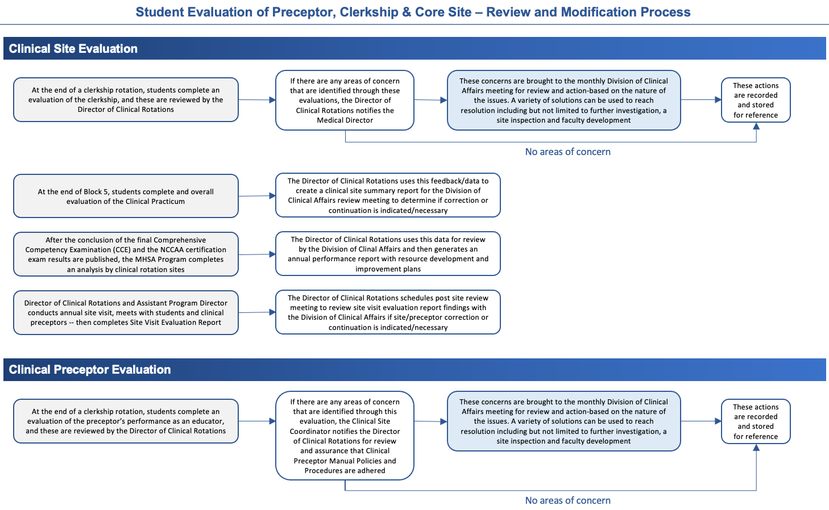

PRECEPTOR QUICK GUIDE TO SUCCESS

  - Review the Welcome to Preceptorship (APPENDIX F)
  - Review the hyperlinked recorded PowerPoint presentation: One Minute Preceptor

Clerkship Facility

The Clerkship Facility should:
  - Provide the student orientation at the beginning of the clerkship
  - Involve the student in the daily educational activities of the facility
  - Provide a supportive learning environment, and support inquiry

Clerkship Preceptor

The Clerkship Preceptor should:
  - Be available to the student
  - Set a regular time during the day for clinical discussions with the student
  - Establish goals with the student to achieve learning objectives

  - Plan learning experiences for the student
  - Provide regular feedback throughout the clerkship
  - Consult with MHSA faculty whenever necessary

Educational Phase

The implementation of an educational plan includes:
- Reviewing the student’s experience
- Discussing patients and cases
- Exploring feelings regarding the experience
- Identifying the meeting of learning objectives

Additional Precepting Considerations

  - The Preceptor is only asked to guide or facilitate student education. You can provide a lecture or simply direct them to read on specific topic.
  - For Core Rotation experiences, MHSA provides learning objectives, syllabi, modules, and reading assignments.
  - Students learn by observation, reading, study, participation, and discussion.
  - Student education is not dependent on volume, but on depth of learning, as well as development of understanding and application of clinical knowledge.
  - Patient satisfaction increases with student presence due to added time with and attention to patients.

Additional Preceptor Resources

An Innovative Approach for Calculating the Work Relative Value Units of Clinical Activities Otherwise Concealed,
Clinical Productivity (2011), Joseph R. Berger, MD, and Richard F. Maher, Jr.
Barriers and Strategies to Engaging Our Community-Based Preceptors, Teaching and Learning in Medicine, Scott C. Graziano, Margaret L. McKenzie, Jodi F. Abbott, Samantha D. Buery-Joyner, LaTasha B. Craig, John L. Dalrymple, David A. Forstein, Brittany S. Hampton, Sarah M. Page-Ramsey, Archana Pradhan, Abigail Wolf & Laura Hopkins (2018)
Cost of an Acting Intern: Clinical Productivity in the Academic Emergency Department, The Journal of Emergency Medicine, Vol. 47, No. 2, pp. 216–222 (2014) Katherine Hiller, MD, MPH, Chad Viscusi, MD, Daniel Beskind, MD, Hans Bradshaw, MD, Matthew Berkman, MD, and Spencer Greene, MD
Incorporating Students into Clinic may be Associated with both Improved Clinical Productivity and Educational Value, Neurology Clinical Practice (2017), Jeremy A. Tanner, MD*; Karthik T. Rao, MD*; Rachel E. Salas, MD; Roy E. Strowd, MD; Angeline M. Nguyen, MD; Alexandra Kornbluh, MD; Evan Mead-Brewer, MHA; Charlene E. Gamaldo, MD
Physicians’ Productivity and Teaching Responsibilities, Academic Medicine (1993), Gary W. Kearl, MD, MSPH and Arch G Mainous III, PhD
Quality of Student Learning and Preceptor Productivity in Urban Community Health Centers, Family Medicine (1998), M Diane McKee, MD, Penny Steiner-Grossman, EdD, MPH, William Burton, MA, Michael Mulvihil, DrPH
The Community Preceptor Crisis: Recruiting and Retaining Community-Based Faculty to Teach Medical Students – A Shared Perspective From the Alliance for Clinical Education, Teaching and Learning In Medicine An International Journal (2016), Jennifer G. Christner, Gary Beck Dallaghan, Gregory Briscoe, Petra Casey, Ruth Marie E. Fincher, Lynn M. Manfred, Katherine I. Margo, Peter Muscarella, Joshua E. Richardson, Joseph Safdieh and Beat D. Steiner

CURRICULUM

The objective of the clinical rotations is to train the graduate student in the competent delivery of anesthesia under the medical direction of a licensed physician anesthesiologist, in compliance with the American Academy of Anesthesiologists Assistants and American Society of Anesthesiologists Statements on the Anesthesia Care Team. The clinical rotations are designed to provide the student with a comprehensive experiential knowledge base in all facets of anesthetic technique and clinical scenarios.

Foundation Year Clinical Immersion

During the first year of the program curriculum students encounter eight weeks of broad education in basic science disciplines relevant to the practice of anesthesiology. This academic year, termed the Foundation Year emphasizes the fundamental aspects of anesthesia, including basic physiology and pharmacology, and the skills involved in the administration of anesthesia and associated invasive and non-invasive monitoring. Much of this year is spent completing the didactic curriculum, with approximately 250 hours of clinical experience in the general operating rooms of adult hospitals. During the Foundation year students develop knowledge and skills in patient assessment and physical examination and optimization, vascular access, and airway management. Clinical experience is intertwined with didactic and simulation-based learning. The Clinical Performance Goals for the Foundation Year are pre-defined and must be satisfactorily completed prior to student promotion to the Integrative Year.

Integrative Year Clinical Practicum

Both clinical and non-clinical learning activities during the Integrative Year are based upon a philosophy of increasingly self-directed learning. The didactic lectures are presented in a seminar format directed toward critical review of literature on selected topics. The year is spent almost exclusively in subspecialty rotations. At the discretion of the Assistant Program Director for Clinical Affairs and Medical Directors, all students in good standing are given the opportunity to undertake satellite elective months. During the Integrative year, students are permitted to complete up to three (3) elective satellite rotations. Additionally, students may voluntarily utilize their vacation time between the fall and winter semesters for additional satellite rotations.

ASSESSMENT

Clerkship Grades
Students must demonstrate progress on the AA Student Milestones assessment, Clinical Preceptor evaluations, and submit all End of Rotation Reflections and pass any applicable Comprehensive Competency Exam to achieve a grade of pass for a clerkship. Honors may not be awarded or may be removed if the student receives marks demonstrating below expectations ratings, recommendation of failure, or professionalism concerns.

All components are required before a final grade is assigned by the MHSA Program:

  - Clinical Preceptor Evaluation from the Preceptor last 5 days of the clerkship
  - End of Clerkship Reflections from the Student last 5 days of the clerkship
    - Evaluation of Clinical Rotation Site
    - Evaluation of Clinical Preceptor
    - Evaluation of Self
  - Comprehensive Competency Examination

Composite Clinical Grading Schema

GPA ACCOUNTABLE GRADE

Component 1: Clinical Evaluation (CEV)

Grading – Likert Scale 1-5 (simple percentage conversion)

Component 2: Clinical Engagement Score (CES)

Graded as a percentage of expected skill acquisition during the Block.

Since we can’t handicap the exposure cadence or density across our entire network, it’s not fair to hold students accountable to every skill category.

Grading based on a composite score of clinical hours, cases, and days as a simple percentage of expected (ex: in Block 2 there were 48 available days for rotation, so a student would be awarded points based on number of days as a percent of 48… They work less, they get less. They do more, they can achieve more points).

Component 3: Clinical Skill Acquisition (CSA)

Graded as a percentage of expected cumulative skill acquisition based on the amount of time spent in clinical practicum experiences.

Ex: There are 10 weeks in Block 2, which is ~14% of total clinical experience time, so we should expect 14% of required clinical experiences be completed by the end of the block (obviously we’ll need to be vigilant about which skills are likely to be encountered in each phase of learning).

Component 4: Assignments (A)

Weekly question (through Block 2, 4-6) – 52 difficult board type questions with expectation to research correct and incorrect answers with justification and proper citations.

Block 2 – submit Anesthesia Care Plan each day signed by preceptor

Blocks 4-6 (alternating requirement to do 2 out of 3 assignments each Block 4-6… I.e., If they don’t have their presentation in Block 4, then they do (2) and (3). If they do their presentation in Block 4, then they do that and (3) – we calculate grade on the two they do each Block.

Assigned topic presentation (Wednesday afternoon conferences – “WACC”)

Pre-curriculum book report – application to anesthesia and patient care

25 Questions – student write 25 Board style MCQ with rationale for correct and incorrect answers with proper citations

Reflective writing or Case Report

Calculation CEV + CES + CSA + A = Clinical Practicum Grade

We can debate / determine appropriate weighting of each element for overall grade.

PASS / HIGH PASS / HONORS DESIGNATION

Composite standard deviation assessment of

P-MEX evaluation (Likert 1-4)

Student Milestones (Likert 1-10)

Clinical Evaluations (Likert 1-5)

We determine appropriate weighting of all three elements, combine into composite score and then determine designation for each Block on variance from the mean.

Clinical Rotation Competency Evaluation (Preceptor Evaluation of Student)

Competency-based rating forms are utilized by clinical faculty when evaluating each student’s clinical skills performance and application of medical knowledge in the clinical setting. The rating forms are completed by the primary clinical faculty member who is precepting the student. The MHSA Program uses a competency-based evaluation form which includes the following core competencies:

    - Medical knowledge;
    - Communication and interpersonal skills;
    - Patient care;
    - Practice-based learning and clinical decision making;
    - Professionalism and ethics;
    - Servant leadership;
    - Systems based learning; and
    - Additional MHSA values and outcomes.

Student competencies are judged by the clinical skill performance. A student’s clinical skills are rated on the form as: unacceptable, below expectation, meets expectation, above expectation, or exceptional. These ratings are compiled and result in a clinical rotation grade that uses the Honors, High Pass, Pass, fail system; these grades are not calculated in the GPA. During the clinical practicum portions of the curriculum, students receive clinical rotation competency grades at the end of each rotation. During the Integrative Phase all rotations have a clinical rotation grade and a clinical modules/CCE/practicum grade, and students must pass both the "module/exam" and "rotation" portions of the course.

In alignment with the requirements of programmatic accreditation, we categorize the outcomes into psychomotor (skill-based), cognitive (learning) and affective (behavior) domains and then further contexualize the specific learning outcomes to define progressive levels of performance for each competency, with the expectation that each student will achieve specific milestones before graduating from the program and taking the national certification examination. Within each of the primary competency dimensions listed above, the program defines skills, behaviors and knowledge expected of a competent Anesthesiologist Assistant that students should be able to perform upon entering clinical practice. These ‘entrustable professional activities’ provide a framework as a practical approach to assessing competence in real-world settings and impact both learners and patients.

Additionally, in the clinical practicum portion of the curriculum, the Clinical Rotation Competency Evaluation is matrixed against definable qualities of the Certified Anesthesiologist Assistant. Outcome measures will be developed based on the performance objectives and core competencies and will include ongoing assessment of knowledge, clinical, procedural, and communication skills, and professionalism. The evaluation system (CREDO) allows real-time assessment of twenty-five milestones mapping to the six core competencies by multiple evaluators during different rotations so that responses can be synthesized into a continuum of trainee skill acquisition and professional development (AA Student Milestones).

End of Clerkship Reflections (Evaluations from Students)

At the end of each clinical experience, students complete End of Clerkship Reflections including an evaluation of the preceptor (APPENDIX D) and evaluation of the clerkship (APPENDIX E). The evaluation information is reviewed by the MHSA Program and feedback is provided to preceptors and clinical sites.

Site Visit of the Clinical Site

The MHSA Program faculty will be conducting announced and/or unannounced site visits on a regular basis. During a site visit, the Clinical Site Coordinator, clinical preceptors, and student are interviewed and the visiting faculty records comments and questions of the preceptor and facility on the Site Visit Questionnaire & Report Forms. The visiting faculty will evaluate the student’s clinical performance, and this will become a component of the rotation grade.

The purpose of the site visit is to ensure ongoing assessment of the clinical educational experience provided at the site, including preceptor(s), case load, patients, facility, and ancillary staff. All clinical sites in which students are present will receive a site visit during the clinical year. The optimal time to visit the site is during the third and fourth week of a given rotation. The site visitor may interview the student and at least one preceptor. Every effort should be made to speak with other staff that may be involved in the teaching, supervising, assisting, or orienting of the student. If a student is not present at the site when a faculty member performs a site visit, the student may be subject to failure of the rotation.

Educational Modules

In addition to being assessed on clinical performance skills during the rotation, students are also assessed on the basic science and medical knowledge acquired through educational modules. The educational modules utilize online cases, required reading assignments, VCOM TV recordings, and other forms of delivery to provide the medical knowledge for the Integrative curriculum. Students are expected to complete all the assigned materials to complete the entire curriculum assigned for the clinical module. The Integrative Phase modules are assigned a traditional letter grade (A, B+, B, C+, C, and F) based on the end-of-rotation exam score and are calculated into the GPA.

Comprehensive Competency Examinations

A total of ten Comprehensive Competency Exams (CCEs) are given during the program to evaluate long-term retention. One exam is the In-Training Exam (ITE) administered by the National Commission for Certification of Anesthesiologist Assistants (NCCAA). The ITE is administered during at the mid-point of both the first and second years and is a summative evaluation of anesthesia and medical knowledge to measure cumulative medical knowledge required for progressing through the Program, as well as that needed for the NCCAA Certification Exam. The student is provided with feedback on areas of weakness in their knowledge base.

Case and Skill Logging

Students are required to maintain a log to identify the procedures performed, and to log the ICD 10 codes of the patient cases seen by diagnosis, to assess the number of essential patient encounters in each core specialty. The faculty member will verify the information at the end of the rotation either online using a password signature, or by signing the log.

Research and Capstone Project

During the Integrative Phase, students are required to complete research and produce a thesis or scholarly paper of publishable quality. This scholarly activity provides students the opportunity to further develop research, critical thinking and writing skills, all while working in collaboration with a clinical faculty member. The Capstone Project is assigned a traditional letter grade (A, B+, B, C+, C, and F) and is calculated into the GPA.

STUDENT POLICIES & PROCEDURES

Attendance Requirements for Integrative Phase Students

Students in the Integrative Phase are expected to attend all clinical rotation days, didactics, case presentations, and simulation workshops with 100% attendance. However, students are allowed two (2) nonconsecutive day absences from a 12-week period and 1 day from a 4-week rotation, when 100% attendance is not required, without requesting an excused absence.

The clinical site will determine the assigned days and hours to be worked within the rotation period. Students are required to attend any orientation the clinical site sets as mandatory prior to any rotation or the clinical year. The orientation sessions vary by site and are required to maintain assignment to the site. Although the clinical site determines the assigned days and hours to be worked, the MHSA Program has established the following guidelines:

- 4-week rotations may not be less than 20, eight-hour days for a total of a minimum of 160 hours and often average 180 hours or greater.
  - Students may be required to work up to 24 days in a 4-week period or 25 days in a1-month rotation, including call and weekends at the discretion of the clinical site.
  - If the clinical site requires longer daily hours or shift work, the student may complete the required hours in less than 20 days with the following specifications:
    - Students should not work greater than an average of 12 out of every 14 days
    - Students should not work more than 12 hours daily, exclusive of on-call assignments.
    - If on-call hours are required, the student should not be on duty for greater than 30 continuous hours.
    - Students may be required to work weekends but in general should have 2 weekends per month free an average of 2 of 7 days per week free.
- 2-week rotations may not be less than 10, eight-hour days for a total of a minimum of 80 hours and often average 100 hours or greater.
  - If the clinical site requires longer daily hours or shift work, the student may complete the required hours in less than 10 days with the following specifications:
    - Students should not work greater than 12 out of the 14 days.
    - Students should not work more than 12 hours daily, exclusive of on-call assignments, and may not complete the 2-week rotation in less than 1 week.
    - If on-call hours are required, the student should not be on duty for greater than 30 continuous hours.
    - Students may be required to work weekends but in general should have an average of 2 of 7 days per week free.

It should be noted that preceptors will have final determination of the distribution of hours, which may vary from this policy but should not in general be less than 160 hours for a 4-week rotation or less than 80 hours for a 2-week rotation. The institution’s Clinical Site Coordinator and assigned clinical faculty determine clinical duty hours. Students are responsible to the assigned clinical faculty and are expected to comply with the general rules and regulations established by the assigned clinical faculty, and/or the core hospital(s), or facility associated with the rotation.

The average student clinical day begins at 6:30 am and ends at 6:30 pm. Students are expected to work if their assigned clinical faculty is working. Some rotations assign students to shifts and in such cases the student may be required to work evening or night hours. If on-call hours are required, the student must take the call; however, the student should not be on duty for more than 30 continuous hours. Students may be required to work weekends, but in general should have two weekends per month free and two of seven days per week free. Student holidays are determined by the clinical site and follow those of other students and/or residents from the clinical site. Students must be prompt and on time for the clinical rotation.

Integrative Phase Tardiness
Tardiness is defined as arriving more than 5 minutes after the scheduled time the preceptor designates as the expected arrival time. Students are expected to arrive on time to all clinical rotations. If a student is late, he/she must notify the Site Coordinator and the preceptor prior to arrival. Students must have a reason for being late such as illness or vehicle issues, and it is not anticipated that this would occur on more than one occasion. Repeated tardiness is considered as unprofessional behavior and is a reason for dismissal from a rotation. Students with repeated tardiness will be referred to the Honor Code Committee.

Didactic, Case Presentations, and Simulation Workshop Attendance
Students are required to attend MHSA and clinical site didactics, case presentations, and simulation workshops as scheduled by the Program. It is the student's responsibility to be aware of this schedule and attend all required activities. The MHSA Program will publish a monthly didactic calendar. Responsibilities to the precepting faculty do not take precedence over required didactics unless so determined by the Assistant Program Director for Clinical Affairs or Medical Director. Students must be prompt to all didactics as well as rotations. In addition to the MHSA sponsored didactics, each rotation may have specific requirements such as case presentations, morning reports, etc.

Mechanism to Verify Attendance – Integrative Phase Students
Clinical site coordinators and preceptors document attendance on the student’s rotation evaluation form. This information is reviewed by the Director of Clinical Rotations, the Assistant Program Director for Clinical Affairs, and the Medical Directors. Additionally, students are required to enable “Location Services” on their smartphones during all clinical practicum activities. The CORE ELMS clinical skills platform can geo-map student’s location when entering procedures and cases. Failure to enable location services while participating in clinical practicum will result in unexcused absence. Repeated occurrences will result in referral to the Honor Code Committee and/or the Progress & Promotions Committee at the discretion of the Assistant Program Director and/or Medical Directors.

Integrative Phase Excused Absences
Excused absences are those that may be expected or unexpected and that meet the criteria for an excused absence as outlined below. Excused absences fall into two categories:
- Planned Excused Absences
- Unplanned Excused Absences

Students must request approval for a planned or unplanned excused absence for 1 or more days absent from the rotation. Regardless of whether an excused absence is granted, students must still complete a minimum of 160 hours for a 4-week rotation and 80 hours for a 2-week rotation to pass the rotation.

Excused absences will not be granted after the fact, except in emergencies as verified by the Assistant Program Director for Clinical Affairs or the Medical Directors.

Students should be aware that preceptors are not required to allow a student to make-up time missed during a rotation and therefore, the make-up requirement is at the discretion of the Clinical Site Coordinator and the Assistant Program Director for Clinical Affairs. Any time missed must be remediated during the rotation for credit to be issued. Students may remediate up to four missed days or 48 hours missed during any rotation period by working on normal days off (e.g., weekends or call shifts).

See below for the policies and procedures for requesting a planned or unplanned excused absence.

Planned Excused Absences for Integrative Phase
Students Planned excused absences are those that a student is aware of a minimum of 30 days prior to the absence and requires an absence from the academic program for 1 or more days absent from the rotation.

Reasons for planned excused absences include the following: conference attendance, court appearance, medical procedures known in advance, weddings requiring participation, and other qualifying planned excused absences. Students requesting a planned excused absence must complete and submit the “Request for a Planned Excused Absence” form and submit all required documentation a minimum of 30 days prior to the requested absence.

Students may obtain the form from the Director of Clinical Rotations or the MHSA website and must return the form and required documentation to the Director of Clinical Affairs. The student may be required to submit additional documentation upon returning from the planned excused absence. Examples of required documentation include proof of conference attendance, subpoena, proof of court appearance, wedding announcement, and other required verification as requested. Final approval may or may not be granted by the Assistant Program Director for Clinical Rotations or the Program Directors.

Planned excused absences will not be granted after the fact.

Integrative Phase Conference Attendance
Integrative Phase students requesting to attend a conference (other than the AAAA or ASA Annual Meeting) must follow the policy and procedures for requesting a planned excused absence. All conference attendance must be pre-approved by the Dean. Only students who do not have any conditional or failing grades can request a planned excused absence for a conference and/or national meeting provided an absence from a rotation does not interfere with the academic work of other students and does not result in the student missing an assignment that cannot be remediated (as determined by the Assistant Program Director for Clinical Affairs).

Integrative Phase students are not allowed to miss core rotations to attend conferences unless required to do so by the Student Council or other high-level position in a student or the AAAA organization. Those who are granted permission to attend a conference are only allowed to attend one conference per year of not greater than three consecutive days. Any time missed for the conference must be made up by the same number of clinical days that were missed by the student.

For Integrative Phase students who hold national leadership positions that require conference attendance, appeals may be made through the Director of Clinical Rotations (who verifies the student’s leadership position and occurrence of the required conference), Assistant Program Director for Clinical Affairs or the Medical Director (who assures the requirements of the clinical rotation are met, including minimum number of days for that rotation and that the clinical site can accommodate the alternate schedule), and the Dean. Such appeals should occur at the beginning of the year so appropriate planning can occur to assure the student has a successful clinical learning experience.

Unplanned Excused Absences for Integrative Phase Students
Unplanned excused absences are those that are unexpected that a student has no advance knowledge of and requires an absence from the academic program for 1 or more days absent from the rotation. Reasons for unplanned excused absences include the following: sudden illness or medical emergency of the student, non-medical emergency, or medical emergency of an immediate family member.

Students who are absent from the academic program for an unplanned absence must complete and submit the “Request for an Unplanned Excused Absence” form and submit all required documentation within 3 days of returning to the rotation. Students may obtain the form from the Director of Clinical Rotations or the MHSA website and must return the form and required documentation to the Director of Clinical Rotations.

Examples of required documentation include: the “Request for an Unplanned Excused Absence” form, obituary and/or funeral literature, and other required verification as requested. Approval for an unplanned absence to be recorded as an excused absence may or may not be granted by the Assistant Program Director for Clinical Affairs or the Medical Directors.

Sudden Illness or Medical Emergency of the Student
The MHSA Program recognizes that absences related to sudden medical illness, or an emergency do occur. If the student has a medical illness or emergency where he or she is physically able to call, the student must contact the Director of Clinical Rotations, the Clinical Site Coordinator, and clinical preceptor by 6:00 AM of the day they will be absent to notify them of the illness or emergency. If the student is physically unable to notify the required parties of the illness or medical emergency, they must call as soon as they are able.

Within 3 days of returning to clinical practicum responsibilities, the student must submit the “Request for an Unplanned Excused Absence” form and any other required documentation. Students may obtain the form from the Director of Clinical Affairs or the MHSA Program website and must return the form and required documentation to the Director of Clinical Rotations. Approval for an unplanned absence to be recorded as an excused absence may or may not be granted by the Assistant Program Director for Clinical Rotations or Medical Directors.

Non-Medical Emergency or Medical Emergency of an Immediate Family Member
The MHSA Program also recognizes that absences related to a non-medical emergency or medical emergency of an immediate family members does occur. If the student has a non-medical emergency or medical emergency of an immediate family members where he or she is physically able to call, the student must contact the Director of Clinical Rotations, the Clinical Site Coordinator, and the clinical preceptor by 6:00 AM of the day they will be absent to notify them of the emergency. If the student is physically unable to notify the required parties of the emergency, they must call as soon as they are able. Upon being contacted by the student, the Director of Clinical Rotations will immediately notify the Assistant Program Director for Clinical Affairs or the Medical Directors of the emergency. The Assistant Program Director for Clinical Affairs or the Medical Directors will contact the student and the student and Assistant Program Director for Clinical Affairs will agree upon the number of excused absence days needed for the situation.

Within 3 days of returning to clinical practicum responsibilities, the student must then submit the “Request for an Unplanned Excused Absence” form and submit all required documentation. Students may obtain the form from the Director of Clinical Rotations or the MHSA website and must return the form and required documentation to the Director of Clinical Rotations. Approval for an unplanned absence to be recorded as an excused absence may or may not be granted by Assistant Program Director for Clinical Affairs or the Medical Directors.

Integrative Phase Unexcused Absences
An absence that is taken but is not granted as a planned or unplanned excused absence or that exceeds the allowable absences for the rotation is considered unexcused.

Consequences for Not Meeting the Requirements of the Attendance Policy
The Director of Clinical Rotations maintains all attendance data.

Students who have repeated requests for excused absences on exam or required curricular days or whose total number of absent days is deemed excessive, are required to meet with the Assistant Program Director for Clinical Affairs or the Medical Directors. If a student is believed to be abusing the excused absence policy, they may be evaluated for an Honor Code violation.

If a student has absences that cause him/her not to meet the hours required by the rotation for multiple rotations, even if approved as an excused absence, has unexcused absences for the rotation, or has unexcused absences for simulation workshops he or she will be brought before the Honor Code Committee. The student should be aware that being brought before the Honor Code Committee will become part of the permanent record of the student as reported on the Comprehensive Anesthesia Student Performance Evaluation (CASPE, also commonly known as the Dean’s Letter).

Students should also be aware that excessive unexcused absences may be presented as evidence during Progress & Promotions Committee Hearings.

The MHSA Program follows the Department of Education academic withdrawal policy guidelines, which require that a student must be withdrawn from the academic program after missing 14 consecutive calendar days (including weekends and holidays) after the student’s last date of attendance.

For more information regarding absences, please refer to the VCOM-Bluefield MHSA Program Student Handbook, or the VCOM-Bluefield MHSA Program Attendance Policy.

Dress Code for Clinical Activities

In clinical settings, professional dress is always expected while on duty. Students should be clean and neatly dressed. Students should be aware they are working with the public and personal hygiene is of the utmost importance. Please be aware that unpleasant odors including strong colognes and perfumes may trigger sensitivities in some patients and students may be sent home by the precepting faculty.

Except in the surgical suite, delivery room, or emergency room where hospital scrubs may be worn, professional dress is required. However, hospital scrubs but may not be worn when commuting to and from the hospital.

When arriving to and leaving from the clinical rotation sites, foot attire for students should include casual dress shoes or closed toe shoes. Casual sandals are not allowed in the clinical setting. Jeans are not allowed in the clinical setting. Male students should wear a collared shirt and tie and a white coat. At the discretion of the precepting faculty, a collared shirt or sweater may replace a tie. Female students should wear a dress or skirt of appropriate length so to not be considered provocative and to be considered professional. Dress slacks are also appropriate with a professional appearing shirt and a white coat.

Dress in the clinical setting should never be provocative for male or female students to assure there are no mixed messages to patients or hospital staff. Students should use good judgment here, if there is a question as to the appropriateness of the dress, the student should ask the precepting faculty prior to wearing. Students dressing inappropriately may be sent home with an unexcused absence requiring a remediation. Repeated episodes may result in the problem being referred to the Progress & Promotions Committee.

Student Identification

The MHSA short white coat and identification badge identifies the individual as an Anesthesiologist Assistant student. Students must wear their MHSA issued white coat and ID badge in all designated clinical settings and to designated and approved events. Students should not wear their white coat or ID badge or verbally represent themselves as representing VCOM, Bluefield University or the MHSA Program for non-Program sponsored events. These include, but are not limited to, shadowing experiences that are not part of the MHSA curriculum, volunteer activities that are not MHSA sponsored, or functions that are not MHSA events such as those that are of a political or social nature.

Students should not give their white coat or ID badge to another student or to an individual who is not a MHSA student. If the white coat or ID badge is missing or stolen, the student must report this to the Associate Dean for Academic Affairs as soon as possible. Not wearing the white coat and ID badge as required, wearing the MHSA white coat or ID badge to non-MHSA sponsored events, or giving or loaning these items to others is considered unprofessional behavior and subject to disciplinary action. Any questions or clarification should be directed to the Associate Dean for Academic Affairs.

Duty Hours

Scheduling is determined solely at the discretion of the core site hospital, service, or preceptor and must be followed without exception. Responsibilities may be required on overnights, weekends, or holidays. Laws mandating restrictions on intern and resident work hours do not apply to Anesthesiologist Assistant students.

Students generally follow the same schedule as their preceptor, however, if the preceptor is on vacation, or scheduled away from the office or hospital, additional arrangements must be made for completion of the clerkship. Students must be enrolled in clinical activities throughout the entire academic year up to graduation. Unreported absences or chronic absenteeism may lead to referral to an appropriate University official.

The clinical site will determine the assigned days and hours to be worked within the rotation period. Students are required to attend any orientation the clinical site sets as mandatory prior to any rotation or the clinical year. The orientation sessions vary by site and are required to maintain assignment to the site. Although the clinical site determines the assigned days and hours to be worked, the MHSA Program has established the following guidelines:

4-week rotations may not be less than 20, eight-hour days for a total of a minimum of 160 hours and often average 180 hours or greater.

Students may be required to work up to 24 days in a 4-week period or 25 days in a 1-month rotation, including call and weekends at the discretion of the clinical site.

If the clinical site requires longer daily hours or shift work, the student may complete the required hours in less than 20 days with the following specifications:

Students should not work greater than an average of 12 out of every 14 days

Student should not work more than 12 hours daily, exclusive of on-call assignments.

If on-call hours are required, the student should not be on duty for greater than 30 continuous hours.

Students may be required to work weekends but in general should have 2 weekends per month free an average of 2 of 7 days per week free.

2-week rotations may not be less than 10, eight-hour days for a total of a minimum of 80 hours and often average 100 hours or greater.

If the clinical site requires longer daily hours or shift work, the student may complete the required hours in less than 10 days with the following specifications:

Students should not work greater than 12 out of the 14 days.

Students should not work more than 12 hours daily, exclusive of on-call assignments, and may not complete the 2-week rotation in less than 1 week.

If on-call hours are required, the student should not be on duty for greater than 30 continuous hours.

Students may be required to work weekends but in general should have an average of 2 of 7 days per week free.

Employment

Students are strongly discouraged from seeking employment during the academic year. The Program reserves the right to preclude employment should it be deemed to adversely affect the student’s academic progress.

Practicing Medicine

MHSA students shall not engage in any activity that may be construed as the practice of medicine or any phase thereof. Students are prohibited from accepting any form of payment or gratuity for their clinical activities. Clinical activities of students are not permitted without the appropriate supervision of a licensed qualified anesthesia provider.

In no event shall a student represent, either directly or indirectly, that the student is licensed to practice as a graduate of this University or otherwise, unless such student is, in fact, a licensed practitioner. Prior license in a healthcare field does not permit the student to represent themselves as a qualified anesthesia provider in any context or under any circumstance.

The determination of whether a student’s activity violates this policy shall be that of the University alone. Students with questions regarding this policy should submit them in writing to a member of Student Services. The Student Services team can counsel students on this policy. Violation of this policy may result in the immediate disciplinary action.

Medical Ethics

All medical students are expected to conduct themselves in a professional manner demonstrating an awareness and compliance with the ethical, moral, and legal values of the osteopathic medical profession. In observing the principles and practices of medical ethics, students will:

- Place primary concern on the patient’s best interests
- Be available to patients at all reasonable times as expected by the preceptor/core site
- Perform medical activities only within the limitations of a student’s capabilities and within the guidelines determined by the site and/or preceptor
- Strictly maintain patient and institutional confidentiality

The Master of Health Science in Anesthesia Program adheres to the posits and premise of the Honor Code developed by the Edward Via College of Osteopathic Medicine as a code of conduct as it relates to the practice of the Certified Anesthesiologist Assistant. The MHSA Honor Code of Contact embodies a spirit of mutual trust, intellectual honesty, and professionalism between the Program and the student body, and it is the highest expression of the values shared by the MHSA community. The Honor Code is based on the fundamental belief that every student is worthy of trust and the students holding themselves and the student body accountable for that trust is an integral component of making them worthy of trust. The Student Honor Code of Conduct is based upon the professional and ethical expectations of an Anesthesiologist Assistant student and future anesthetist in training. The Honor Code of Conduct is maintained by the students for the student body to protect their right to participate in an academic environment free from injustice caused by dishonesty and a health professions environment that embraces professionalism and ethical behavior. The MHSA Student Honor Code is upheld by the Student Council.

Diversity and Inclusion in the MHSA Program

Bluefield University, VCOM and the MHSA Program are deeply committed to cultivating diversity and inclusion on its campuses and in its programs and to challenging our students to embrace cultural proficiency and adeptness. As future healthcare professionals, students must understand and embrace cultural diversity to be competent and successful in team-based healthcare delivery. The Program’s faculty and staff must do the same.

MHSA students, faculty, and staff serve diverse, underserved, at-risk, urban, and rural populations within geographically diverse communities nation-wide. In addition, the MHSA Program’s alumni will work to serve diverse communities all over the United States.
Furthermore, the institutional strategic plans of both Bluefield University and VCOM call for the creation of a culture of inclusion, by securing more students, faculty, and staff from diverse backgrounds and enhance a campus sense of community. Our universities’ strategic plan outlines our priorities and best practices to achieve diversity through on-going and vigilant evaluation of our institutional community. Students wishing to know and understand more about the institutional effort to enhance diversity and inclusion on-campus can contact the Provost’s Office.

Student Discipline Procedures

Complaints involving alleged misconduct by students in will be handled according to the following procedures except in those cases where different procedures are prescribed by another Program or University policy (e.g., allegations of sexual harassment, research misconduct). The MHSA Program has established a multi-dimensional approach to adjudicating student misconduct, poor academic performance and/or disciplinary issues. The following steps are to be followed in any case where a student is alleged to have violated the MHSA Honor Code of Conduct as enumerated in MHSA Student Handbook:

- All reports of code violations shall be reported to Student Services, Student Council leadership, and/or the Associate Dean for Academic Affairs. Reports must be filed in writing and must be signed by the reporting party.
- The report will be reviewed, and a determination made if the charge is of the nature to merit an investigation of the allegation(s).
- If the charge is of a nature to merit an investigation, the Honor Code Committee, along with the Director of Student Services will gather, analyze, and investigate the information. (This will be done as quickly as possible, but sometimes the nature of such investigations takes longer to gather evidence and speak with potential witnesses.)
- After all information is gathered, the Honor Code Committee will apply a preponderance-of-the-evidence standard in making a judgment about the validity of the grievance and will then decide how best the alleged misconduct should be adjudicated. The multidimensional nature of the MHSA’s disciplinary system allows for cases to be heard by the Progress & Promotions Committee, the student-run Honor Code Committee, or the Dean for Anesthesiologist Assistant Programs.
- The Associate Dean for Academic Affairs will make the final decision as to how the case will be heard and will make a referral to the specific adjudicating body for disposition of the case. The student will also be notified in writing to appear before the appropriate body to have their case heard.
- In cases where the information does not merit referral to the PPC or the Honor Code Committee, the case will be dealt with by the Student Council.
- Once the case has been formally adjudicated, the Student Council, the PPC or the Dean will then communicate in writing the outcome to the individual(s) involved.

The University reserves the right to address inappropriate behavior that does not clearly fall within the identified MHSA Honor Code of Conduct.

STUDENT SAFETY & COMPLIANCE

Affiliation Agreements

The MHSA Program has affiliation agreements with all sites where core clerkships are completed. Some elective clerkships will require an affiliation agreement to be signed between the Program and the visiting site where one does not already exist. (Affiliation agreements usually address issues such as liability, academic supervision, and faculty appointments.) If an affiliation agreement is required from a visiting site, it is the student’s responsibility to complete a Request for Elective Rotation form (APPENDIX G) and notify their Director of Clinical Rotations and report the appropriate contact information and other pertinent details for the desired clerkship. Some affiliation agreements take up to six (6) months to process and it is in the student’s best interest to begin the process as soon as possible. The Program cannot guarantee consensus will be reached with every facility or preceptor. If an agreement cannot be made between the Program and the visiting site, the student must withdraw their application and will not be allowed to rotate at that particular site.

In Case of Emergency

Students should always follow emergency procedures and protocols at their specific clinical site. In the event that the clerkship schedule is interrupted due to hazardous weather conditions or another emergency situation, please notify the MHSA Division of Clinical Affairs as soon as possible.

In the case of inclement weather, students on clerkships do not follow the same attendance requirement as Foundation Phase students. Students on clinical clerkships are to follow the schedule of the site where they are rotating. If the site is closing due to inclement weather, then the student is excused until the site re-opens. If the student is at a hospital or site where they are not closing, the student is to report and remain on-service until the end of their shift. Students should use caution and allow themselves plenty of time to get to their destination.

Counseling & Support Services

The University understands the intense environment and extra stress that graduate students experience. Because it is important for students to be emotionally healthy, students are encouraged to utilize the counseling services that are available to them. VCOM has two licensed counselors on campus. Students are encouraged to set up appointments by emailing the respective counselor they would like to see.

The MHSA program is privileged to use VCOM’s Mental Health Counselors who aid students experiencing individual stressors and/or difficulty with personal levels of functioning and are available for any student seeking assistance with preserving or restoring their mental health. The assistance provided to students is conceptualized holistically with attention to contextual influences on persons’ lives influenced by the stress of graduate school and in relationship to their family, societal, historical, cultural, and socioeconomic concerns.

The counseling sessions are available to address emotional and social issues that may be impeding the student’s progress. The counseling services at VCOM focus on wellness and a holistic approach to mental health. All student information gained during the counseling sessions are confidential to the student and counselor (unless required by law for a student at considered at risk).

To schedule an appointment, students should call or email VCOM’s Mental Health Counselor or contact CIFSS for assistance in making the appointment if needed. Appointments may be conducted as in-person meetings or via Zoom or phone if a student is located away from campus.

While VCOM provides confidential counseling services, students may also utilize the external counseling services outside of VCOM (see info below). These services include a 24-hour emergency counseling services hotline that is available to support students outside of regular hours. Students who require psychiatric support or physician’s evaluation and support will be referred for external medical/counseling services.

The licensed psychologists provide immediate support for students through psychotherapy, proactive support programs to assist students with the extra stresses associated with medical school and graduate study. They provide additional information and support through the University’s orientation program. They can also assist students who are dealing with any kind of substance abuse or addiction issue.

VCOM-Bluefield MHSA Program

Rebecca Hoyt, Ed.S

Director of Student Academic Success

rhoyt@auburn.vcom.edu

VCOM Counseling Contacts

AUBURN

Mary Ann Taylor, MS, PhD

Assistant Professor for Psychiatry & Neuro-Behavioral Science

mtaylor@auburn.vcom.edu

CAROLINAS

Natalie Fadel, PsyD

Director for Counseling Services

Associate Professor for Psychiatry and Neuro-Behavioral Sciences

nfadel@carolinas.vcom.edu

In addition to VCOM’s Mental Health Counselors who provide confidential counseling services, VCOM contracts with mental health providers in the campus community to assure that MHSA students have readily accessible mental health services when preferred by the student. The fee for the first four visits, per incident, are covered by the agreement between VCOM and these agencies and is free to students and their immediate families. Visits beyond this will be at the expense of the student (or the student’s family member). The purpose of the sessions will be: (1) to provide crisis intervention and counseling services; (2) to determine the participant’s need for assistance, counseling, and treatment; or (3) if appropriate, to refer the participant to one or more resources for assistance or treatment.

Auburn Psychology Group
861-D North Dean Road
Auburn, Alabama 36830
(334) 887-4343
www.auburnpsychology.com
24-hour Crisis Telephone Service: (334) 524-5858

Spartanburg Area Mental Health Center
250 Dewey Avenue
Spartanburg, SC 29303
Non-Emergency: (864) 585-0366
24-hour Crisis Telephone Service: (864) 858-0366 or 1-800-277-1366

Physical Health Services

Student health services, through an on-site clinic, are not provided or contracted by Bluefield, VCOM or the MHSA Program. However, MHSA students may seek healthcare through a group of off-campus, endorsed clinical providers who have affiliations with the University. The MHSA Program encourages students to establish a healthcare home with a primary care provider. Frequently, being an established patient enhances how quickly you can be seen for a problem. If a student requires chronic care or needs to be seen during off- hours, he/she should contact his/her own provider. Clinic information is available via Student Health Resources. Students need to present their insurance card when seeing any healthcare provider. All expenses for health services are the responsibility of the student.

Hospital Rules and Regulations / Financial Responsibilities

Each hospital/health care system has individual rules and regulations. Anesthesiologist Assistant students must familiarize themselves with and adhere to these protocols during training. Students must respect and follow all policies regarding the use of hospital facilities, housing, and equipment.

Students are financially responsible for any damage to or loss of hospital or training site-related property, including but not limited to library materials, pagers, and keys. Final grades may be withheld pending return of all hospital or training site property.

Health Insurance

Medical insurance is a mandatory requirement for all MHSA Program students. The MHSA Program provides medical insurance for its students. Students who do not wish to participate in the Program’s medical insurance program must seek and be approved for waivers from participation. Students who wish to obtain a waiver must present proof of health insurance at registration and every six months thereafter, including immediately prior to third year clinical rotations. Medical insurance must be carried through all 28-months for continued enrollment. Students who fail to do so are subject to suspension. The benefit terms of the medical insurance are provided to students annually.

If medical students provide their own medical insurance the minimum requirements are:

- Deductible Maximum: $2,500
- Lifetime Maximum (suggested): $1,000,000
- Co-Pay: Students should seek no higher than 30% co-pay with insurance covering at least 70% up to $5,000 maximum and 100% payment by insurance after $5,000 is met.

Students are responsible for their own personal health costs and insurance coverage if not under the offered medical insurance policy.

Medical Professional Liability Insurance

Students currently enrolled as full-time students in good academic standing and who are expected to graduate with the degree of Master of Health Science in Anesthesia are covered by Bluefield University's liability insurance coverage on approved curriculum such as clinical rotations and required educational activities that are a part of the MHSA Program curriculum and if they are following the policies set forth by the institution. Students should not participate in patient care without supervision and should not perform procedures without direct observation. The coverage for students extends only to clinical situations where the care is performed as a part of the clinical program and when under the supervision of qualified anesthesia provider faculty.

Worker’s Compensation Insurance

Medical students are not employees of the University; therefore, VCOM nor Bluefield University do not provide worker’s compensation insurance. The purchase of required coverage may be offered at the facility. Any expense incurred is the student’s responsibility.

Vaccinations/Immunizations

Regulatory and legislative authorities require that students demonstrate immunization, immunity, or protection from multiple contagious diseases before being allowed to participate in clinical experiences at the institutions utilized by the MHSA Program for the education of its students. The MHSA Program requires that students meet all immunization requirements prior to matriculation and must maintain compliance with these requirements throughout their tenure.

Students must return the MHSA Immunization Form and Tuberculosis Screening/Testing Form, signed by the physician, nurse practitioner, or physician assistant to the Director of Clinical Rotations by the dates specified in the admission policies to maintain acceptance status. The form can be found on the MHSA website at: https://www.bluefield.edu/academics/programs-of-study/mhsa-accepted-student-information/

The MHSA Program requires the following laboratory tests and immunizations:

- Diphtheria, Pertussis and Tetanus
- Annual Tuberculosis (TB) test
- Hepatitis B Virus (HBV) immunization and titers
- Hepatitis C Virus (HCV) test
- Measles (Rubeola), Mumps, and Rubella (MMR)
- Varicella
- Influenza
- COVID-19

Descriptions of immunization requirements can be found on the MHSA website at: https://www.bluefield.edu/academics/programs-of-study/mhsa-accepted-student-information/. Required laboratory tests and immunizations may change annually based on recommendations from the Centers for Disease Control (CDC), the

United States Prevention Task Force (USPTF), other public health agencies, and healthcare facilities. Students will be notified of any changes and will be required to comply with any mandated changes upon receipt of notice from the Program.

Criminal Background Check & Drug Screen

A background check is mandatory prior to matriculation and will be required on one or more occasions during enrollment in the MHSA Program. A background check is required to assure the applicant is not a risk to fellow students, faculty, staff, or patients and to assure the applicant or student has the appropriate insight and judgment to participate in clinical care and to become a physician professional with ethical behaviors. Applicants and students should also be aware certain violations on a background check may be an impediment to licensure or obtaining a residency position upon graduation. Failure to report an arrest or criminal charge during the application process that is later found on a background check will result in a Committee on Progress & Promotions Committee hearing.

MHSA students have periodic background checks performed during curricular continuum. Current or accepted students involved in an arrest or criminal charge for any illegal behavior (whether guilty or not guilty) while in the Program must be reported to the Associate Dean for Academic Affairs within 72 hours from the time of the incident.

Students who do not report an arrest or criminal charge while a student are considered as acting in an unprofessional and/or unethical manner and may be suspended until a Committee on Progress & Promotions Committee hearing is held. The student is advised that a recommendation by a third party (such as a lawyer or fellow student) to not report an arrest or criminal charge is not an acceptable excuse to not follow this policy.

Tuberculosis Test

Each student will be required to complete TB testing annually. Some sites may require additional or two step testing. If a positive TB skin test was documented, one or more of the following must be provided for verification and review:

  - A TB blood test that verifies a negative result
  - Documentation of the completion of successful INH therapy

Prior to matriculation, students must submit their medical history and physical examination and documentation of the listed laboratory tests and immunizations on the following MHSA forms: Physical Exam Form, Immunization Form, and Tuberculosis Screening/Testing Form. These forms can be found on the MHSA Program website at: https://www.bluefield.edu/academics/programs-of-study/mhsa-accepted-student-information/. These forms must be completed, signed, and dated by a licensed physician, nurse practitioner, or physician assistant and returned to the MHSA Program by the dates specified in admission policies to maintain acceptance status.

Influenza / COVID-19

MHSA students are entering the health professions. As part of their education, from time to time they will encounter vulnerable populations who may be at risk for infectious disease. Due to this, all MHSA students are required to be immunized annually for influenza and as recommended for COVID-19.

Basic Life Support (BLS) and Advanced Cardiac Life Support (ACLS)

Prior to starting clinical practicum in Block 2 of the Foundation Phase, students become BLS and ACLS certified. This certification is good for two years. It will expire shortly after graduation.

Needle Stick Policy/Exposure to Blood and Body Fluids

Occupational exposure to blood borne pathogens may occur during patient care activities and it is critical that students understand the actions they need to take to protect themselves. Any student who sustains a needle stick or other wound resulting in potential exposure to blood or body fluids should immediately wash the affected area with soap and water. If the exposure involves the eyes or mucous membranes, they should be immediately flushed with copious amounts of water. Following irrigation of the affected area, the exposure should be immediately reported to the appropriate clinical supervisor. As supervisory faculty will vary based on the type of clinical experience, students should refer to the Exposure Report Form which will provide additional guidance. Finally, all students involved in an occupational exposure must seek medical attention to ensure that appropriate medical care relating to the exposure is provided. This medical follow up is time sensitive and must occur within 2 hours if the exposure involves a known HIV positive source or within 4-6 hours for all other exposures. The VCOM Exposure Report Form provides students step-by-step guidance through these processes, including the acceptable medical care follow up for an exposure incident. Please note that students must complete the Exposure Report Form and return it to the Director of Clinical Rotations within 24 hours of the exposure.

As discussed above and on the Exposure Report Form, timely medical follow up is essential. When reviewing the acceptable medical follow up options on the Exposure Report Form, it is important for all students to recognize that they are not employees of any hospital, clinic, or practice where they are rotating and are therefore not covered under workman’s compensation or the policies of the institution if they suffer an accident or injury. All students are required to carry medical insurance to cover the expense of such an unlikely event and provide coverage for the laboratory testing and prophylactic medications that may be required.

Medical care evaluation after an exposure must occur in a professional setting as described in the Exposure Report form and involves the establishment of a formal doctor-patient relationship and generation of a medical record that can be utilized by the student and their physician in any subsequent or follow up care that is required. This is protected health information and should not be submitted or reported to the MHSA Program.

Students are reminded that they are individually responsible for any charges that may occur because of evaluation and treatment. Some institutions will provide initial screening and treatment for students that are exposed on their campuses. In addition, institutional policy at hospitals and medical clinics may provide for testing of source patient blood to include rapid HIV and hepatitis C testing. However, regardless of whether an institution provides this source testing, students are still required to obtain medical care consultation within the time frame described in the Exposure Reporting Form. Students are reminded that HIV drug prophylaxis, when indicated, is time sensitive in a high-risk exposure.

HIPAA Regulations and Patient Encounters

All students are required to become familiar with and adhere to all aspects of the Health Insurance Portability and Accountability Act (HIPAA) of 1996, Public Law 104-191 including The Privacy Rule published by the US Department of Health and Human Services (HHS). The Privacy Rule establishes, for the first time, a foundation of Federal protections for the privacy of Protected Health Information (PHI). This rule sets national standards for the protection of health information, as applied to the three types of covered entities: health plans, health care clearinghouses, and health care providers who conduct certain health care transactions electronically. By the compliance date of April 14, 2003 (April 14, 2004, for small health plans), covered entities must implement standards to protect and guard against the misuse of individually identifiable health information. More specific information may be obtained at www.hhs.gov/ocr/hipaa/.

As a student in the health professions, these standards pertain to all individually identifiable health information (Protected Health Information or PHI) encountered during medical training with the University including, but not limited to, medical records and any patient information obtained.

HIPAA regulations prohibit the use or disclosure of PHI unless permitted or required by law therefore, each student must utilize reasonable safeguards to protect any information he or she receives. Each student is responsible for ensuring the safety and security of any written or electronic information he or she receives, creates, or maintains. The misplacement, abandonment, or loss of any information in the student’s possession will result in disciplinary action. At no time should a medical student alter, remove, or otherwise tamper with medical records. Specific rules and regulations with respect to student entries in medical records must be clarified during orientation or on the first day of the clerkship.

Furthermore, each student is responsible for ensuring that PHI is used or disclosed only to those persons or entities that are authorized to have such information. Students are expected to maintain strict confidentiality in their patient encounters; to protect the physician-patient privilege; and to ensure that there are no unauthorized uses or disclosures of PHI.

Any unauthorized use or disclosure of PHI, to include but not limited to digital images, video recordings, or any other patient related materials, committed by a student, or any observation of the same by a student or employee, should immediately be reported to the MHSA Division of Clinical Affairs.

Title IX Training – Non-Discrimination and Anti-Harassment

The MHSA Program recognizes, values, and affirms that diversity contributes richness to the college and enhances the quality of education. Students, faculty, staff, and administrators are valued for their diversity. VCOM, Bluefield University and the MHSA Program are committed to providing an academic and employment environment in which students and employees are treated with courtesy, respect, and dignity. It is the policy of the MHSA Program that no student or employee shall, based on sex, be discriminated in, or be denied the benefits of, any education program or activity that it operates. This requirement not to discriminate is required by Title IX and Part 106 of Title 34 of the Code of Federal Regulations and extends to admission and employment. Inquiries about the application of Title IX and Part 106 to VCOM may be directed to the VCOM or Bluefield University Title IX Coordinator, to the Assistant Secretary of the Department of Education, or both.

Bluefield University is a private, not-for-profit institution affiliated with the Baptist General Association of Virginia. Bluefield University will not unlawfully discriminate on the basis of race, color, national or ethnic origin, sex, disability, age, religion, genetic information, veteran or military status, or any other basis on which the University is prohibited from discrimination under local, state, or federal law, in its employment or in the provision of its services, including but not limited to its programs and activities, admissions, educational policies, scholarship and loan programs, and athletic and other University-administered programs. The institution encourages women, minorities, veterans, and individuals with disabilities to apply.

VCOM’s commitment to the principles of nondiscrimination includes and extends far beyond the federally protected classes and includes, but is not limited to, age, gender, sex, race, color, creed, national origin, religion, ancestry, marital status, ethnicity, disability, sexual orientation, gender identity, status as a protected veteran, or any other category protected by federal, state, or local law. VCOM has a commitment to nondiscrimination against any individual or group of individuals. VCOM has no tolerance to inappropriate behavior exhibited as an act of discrimination.

Those persons who believe they are experiencing discrimination should review the procedures for grievances found in the MHSA Student Handbook.

Any person having inquiries concerning VCOM or Bluefield University’s compliance with the regulations implementing Title VI, Title IX, or Section 503, is directed to contact the Director of Human Resources, who serves as the Title IX Coordinator for the campus at:

VCOM-Auburn Campus
Sarah Herren, Director for Human Resources
Office 221
Phone: (334) 442-4031

VCOM-Carolinas Campus
Jean Harris, Director for Human Resources
Building 364
Phone: (864) 327-9841

Any person may also contact the Assistant Secretary for Civil Rights, U.S. Department of Education, regarding either institution’s compliance with the regulations.

Family Educational Rights and Privacy Act of 1974 (FERPA)

The Family Educational Rights and Privacy Act (FERPA) requires educational institutions to annually notify students, in attendance, of their rights under the act regarding access to their education records and certain protections regarding the privacy of personally identifiable information in those records. This policy is issued in compliance with that requirement.
Bluefield University and the MHSA Program strive to uphold the rights of students and families set forth in the FERPA Act of 1974 and all current FERPA regulations. The act places certain restrictions and limitations on the disclosure of personal identifiable information maintained by Bluefield University with respect to students, and it limits access to educational records, including the right to access, the right to obtain copies, the right to seek correction of such records through informal and formal internal procedures, and the right to place a statement in such educational records explaining any information that the student believes to be inaccurate or misleading.
Bluefield University and the MHSA Program consider certain information to be “directory information” under FERPA and therefore subject to disclosure without prior consent from the student. Bluefield University will treat name, address (permanent and mailing), telephone (land and cell), Bluefield email address, date and place of birth, major field of study, dates of attendance, enrollment status, degrees and awards received, the name of the prior college(s) attended, residency program matched, photographs, participation in student activities, and marital status as directory information. A student has the right to refuse the designation of any or all the types of information about the student as directory information by the student giving written notice to Bluefield University no later than 30 days of the commencement of the academic year stating he or she does not want any or all the types of information about the student designated as directory information. Student social security numbers will be provided as requested in the registration process for the NCCAA National Certification Exam. For only this purpose, the social security number will be considered directory information, subject to disclosure without prior consent from the student. Bluefield University nor the MHSA Program shall not disclose the address, telephone number, or email address of any student pursuant to 34 CFR 99.31 (a) or the Virginia Freedom of Information Act unless the student has affirmatively consented in writing to such disclosure.
Information on all students admitted to Virginia’s public and private institutions of higher learning may be submitted to the state police for checking against the sexual offender registry. Bluefield University is required to submit information in the case of an official subpoena, and as required by the state and federal government.
For the purposes of operating the daily academic programs, Bluefield University and the MHSA Program have the right to share academic and behavioral record information internally with school officers such as faculty, administration, and pertinent staff who have a legitimate interest in the information. All employees of VCOM, Bluefield University and the MHSA Program are informed of their responsibility not to share student information outside the institution or with persons within the institution who do not have a legitimate interest.
The MHSA Program will contact immediate family only for the purpose of assuring the students safety and the safety of others. Students concerned about the confidentiality of records at Bluefield University are requested to bring their concerns first to the attention of the Office of Student Affairs. Complaints regarding alleged violations of rights accorded students by or regulations promulgated by the Act, may be directed to:

The Family Educational Rights and Privacy Office
Dept. of Health, Education, and Welfare
330 Independence Avenue, SW
Washington, DC, 20201.
Education Records: Those records, regardless of how the information is recorded, that directly relate to a student and are maintained by this University or by a party acting for this University. However, they do not include:
- Records kept in the sole possession of the maker, that are used only as a personal memory aid, and are not accessible or revealed to any other person except a temporary substitute for the maker of the record.
- Records of the University’s law enforcement unit that are created by it for law enforcement purposes and maintained by it.
- Records relating to an individual who is employed by the University (except if the individual is a student employed because of his/her status as a student) that are made and maintained in the normal course of business, relate exclusively to the individual in that individual’s capacity as an employee and are not available for any other purpose.
- Records on a student 18 years of age or older made or maintained by a physician, psychiatrist, psychologist or other recognized professional or paraprofessional acting in his/her professional capacity or assisting in a paraprofessional capacity so long as the records are made, maintained, or used only in connection with treatment of the student and are disclosed only to individuals providing treatment.
- Records created or received by this University after the student is no longer in attendance and are not directly related to the individual’s attendance as a student.

Personally Identifiable Information: Includes, but is not limited to:
- The student’s name
- Name of parents or other family members
- Address
- A personal identifier
- Other indirect identifiers (e.g., date and place of birth, mother’s maiden name)
- Other information that, alone, or in combination, is linked or linkable to a specific student and would allow a reasonable person who does not have personal knowledge of the relevant circumstances to identify the student with reasonable certainty
- Information requested by a person who the University reasonably believes knows the identity of the student to whom the education record relates.

The Right to Review and Inspect

Students have the right to inspect and review their education records within 45 days of the date the University receives a request for access. Students should submit to the Registrar a written request that identifies the record(s) they wish to inspect. The Registrar will make arrangements for access and notify the student of the time and place where the records may be inspected. If the records are not maintained by the Registrar, that official shall advise the student of the correct official to whom the request should be addressed
Please note the following:
- This right does not extend to the financial records, including any information those records contain, of the student’s parents. Also, certain restrictions apply to a student’s access to confidential letters and confidential statements of recommendation placed in a student’s education records. Additionally, certain records may not be accessed by the student because they are excluded from FERPA’s definition of “education records.”
- If circumstances effectively prevent the student from exercising this right to inspect and review his/her education records, the University will either provide the student a copy of the requested records or make other arrangements for the student to inspect and review them.
- The University will not charge a fee to search for or to retrieve a student’s education records but may charge a fee for a copy of those records, unless doing so would in some way effectively prevent the student from exercising this right.

The Right to Opt-Out of the Disclosure of Directory Information

Pursuant to FERPA, the University has classified certain personally identifiable information as directory information, which may be released without the student’s consent.

This University defines directory information as: the student’s name; local and home addresses; telephone number; email address; place and date of birth; program of study; dates of attendance; enrollment status; participation in officially recognized activities; degrees, honors, and awards received; and the location, training institution, and medical specialty identified for postdoctoral education. A student ID number, user ID, or other unique personal identifier used by a student for purposes of accessing or communicating in electronic systems may also be deemed directory information, but only if that identifier cannot be used to gain access to education records, except when used in conjunction with one or more factors that authenticate the user’s identity (e.g., PIN, password). Any such means of authentication must only be known or possessed by the authorized user.

FERPA permits the University to limit the disclosure of directory information to specific parties, for specific purposes, or both. In the exercise of that authority, this University may release all directory information to school officials as defined above. Other releases will be limited to those situations in which the University, in its discretion, believes the release would recognize a student for academic or extracurricular achievement or otherwise advance the student’s career interests or when the University believes the release would serve to advance the interests and image of the University. Examples of such releases would be the disclosure of directory information to prospective employers, financial aid and scholarship agencies or to registry, licensure or certification services. Another example would be the release of directory information in connection with University sanctioned alumni affairs. The University will not release directory information to persons or parties not affiliated with the University when their intent is to use that information for commercial purposes.
Students who wish to opt out of the release of some or all of their directory information must notify the Registrar in writing during the first 10 academic days of each academic term. Upon receipt of such request, the Registrar will designate that portion of the student’s directory information as confidential and not to be released outside this University except to individuals, institutions, agencies and organizations otherwise authorized by FERPA.
This University will honor all requests to withhold any of the categories of directory information listed in the written request but will not assume any responsibility to contact the student for subsequent permission to release that information. Nondisclosure will be enforced until the student subsequently authorizes its release. A student may not, however, opt out of the disclosure of the student’s name, identifier, or University email address in a class in which the student is enrolled.
Regardless of the effect on the student, this University assumes no liability for honoring the request of the student to restrict the disclosure of directory information.

APPENDICES

APPENDIX A (Clinical Faculty Application)

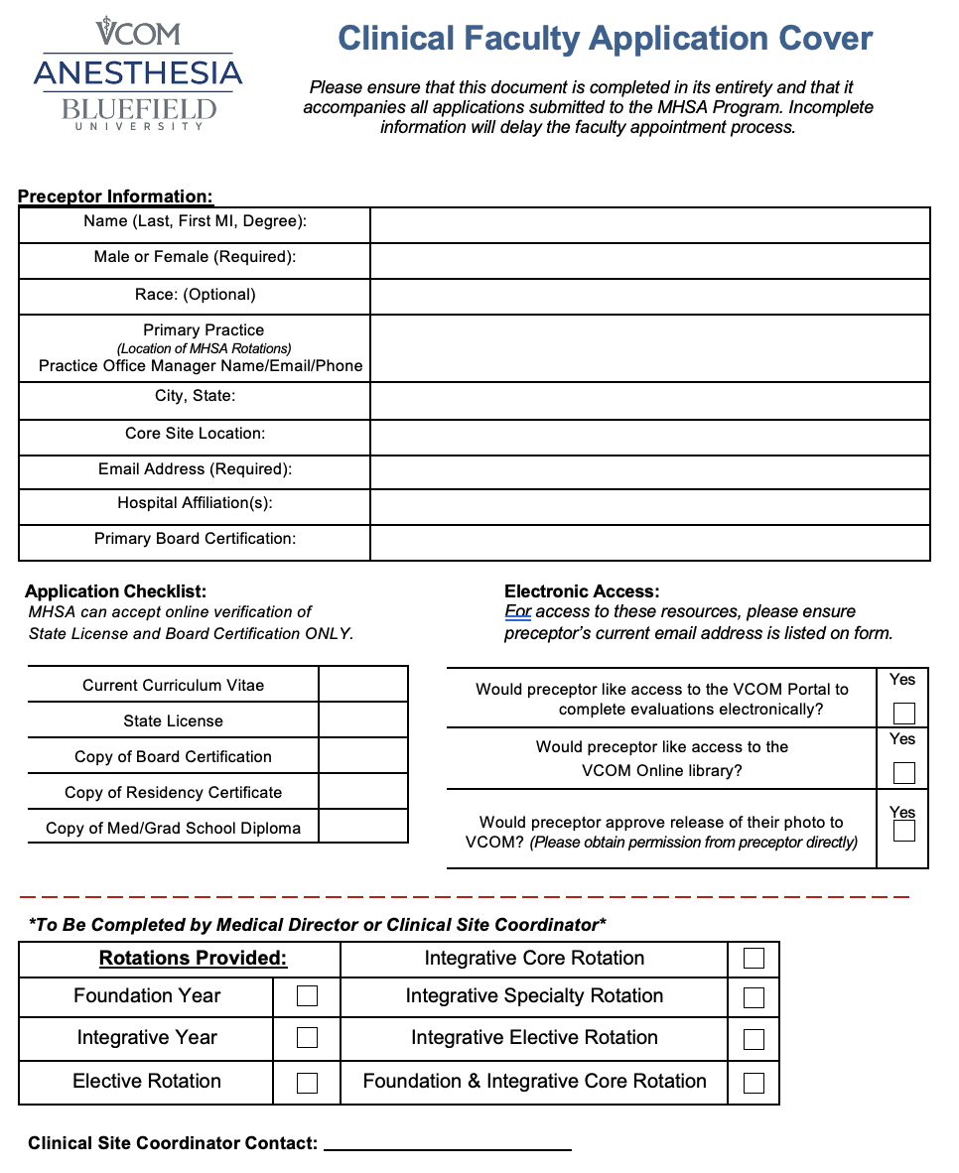
APPENDIX B (Clinical Practicum Preceptor Sample)

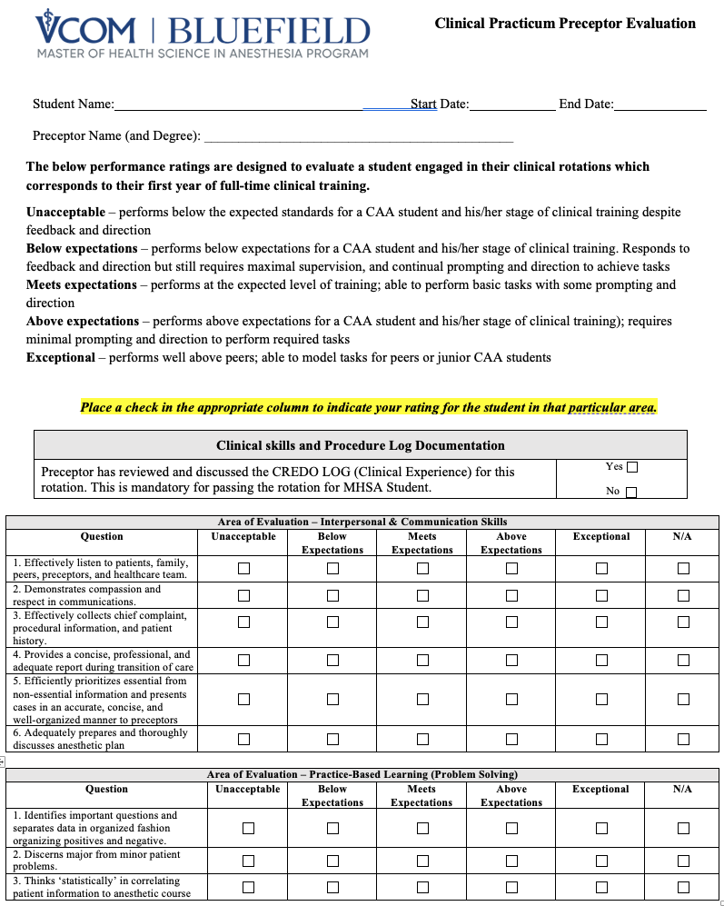

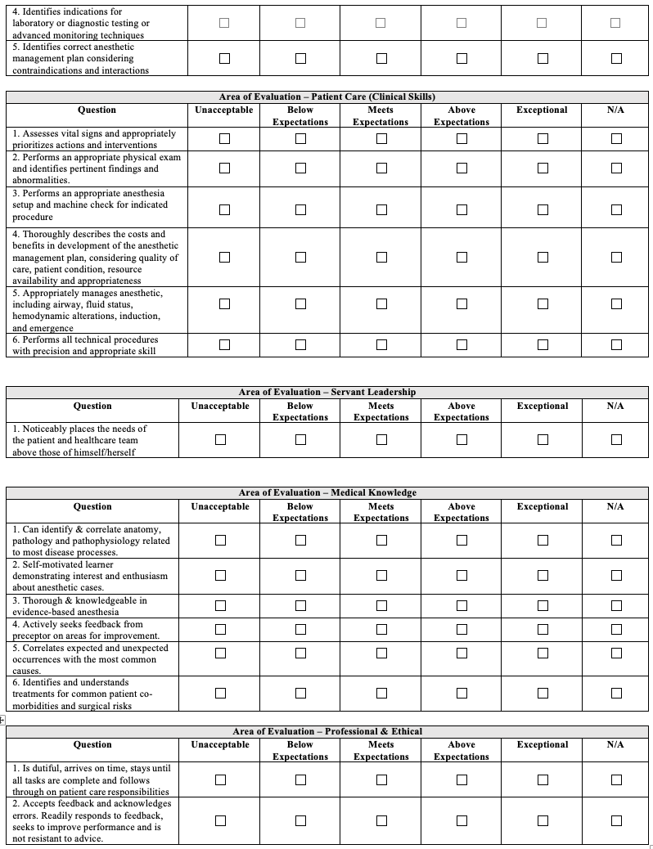

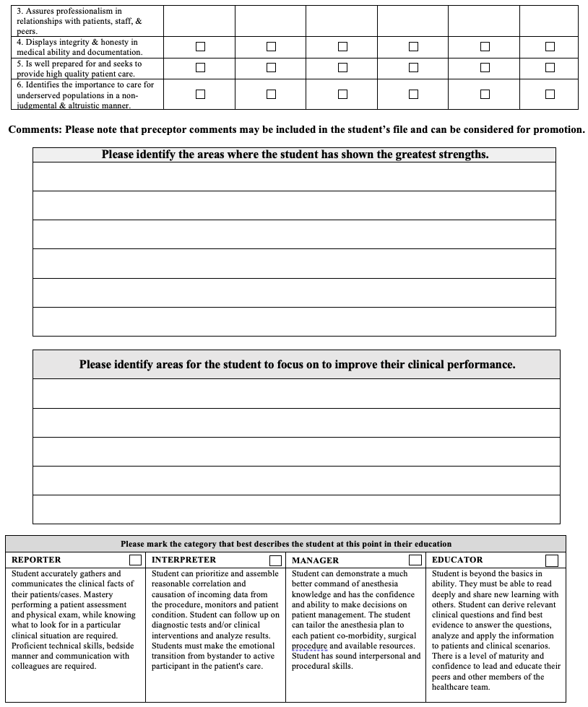

APPENDIX C (Mid-Rotation Clinical Practicum Evaluation)

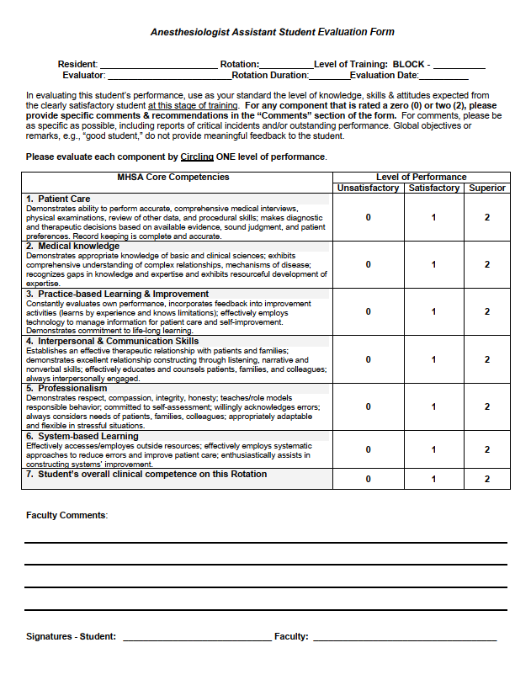

APPENDIX D (Student Evaluation of Preceptor)

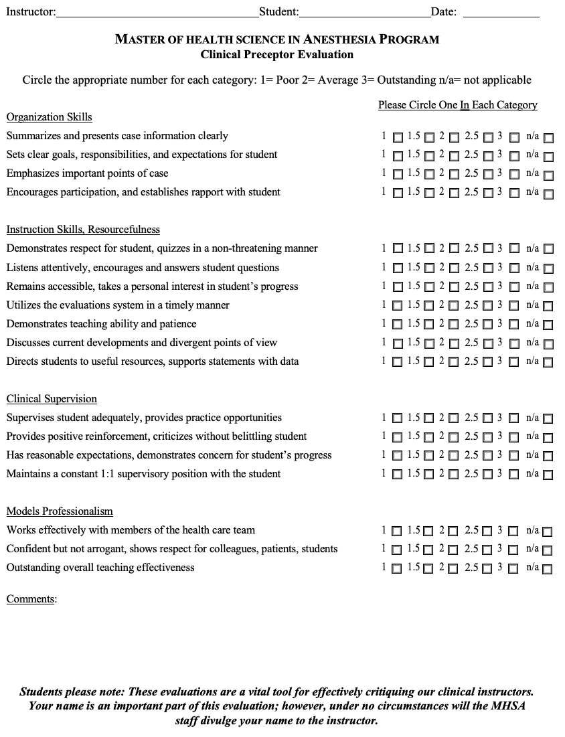

APPENDIX E (Student End of Rotation Reflection)

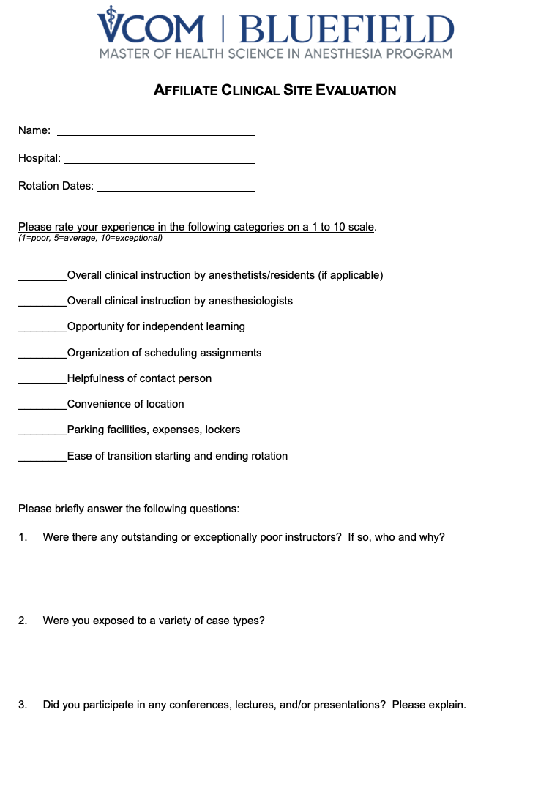

APPENDIX F (Welcome to Preceptorship!)

Clinical preceptors play a key role in the education of Anesthesiologist Assistant students! Beyond what can be learned from a textbook or in the classroom, every clinical preceptor has a personal store of wisdom and experience – students benefit from these insights.

Your role as a mentor for future CAAs is to expand their knowledge base, to help them practice new skills, to enable them to problem solve, and to emulate you as a clinician and a member of the healthcare community. Likely there are things you wish you knew when you first started practice. Integrating the students can be fun! Have students meet your team and interact with them – tell them something unique about you.

Affiliation Agreement
- Between the school and the health system/practice/group
- Required for CAAHEP accreditation

Faculty Appointment
- Credentialing paperwork requested CV and Practice Profile

Placement Request
- MHSA Director of Clinical Rotations and Assistant Program Director for Clinical Affairs
- Local hospital contacts

Student Arrival and Orientation
- Course objectives and evaluation
- Tips for integrating students into your clinical practice

Formative Feedback
- Mid-rotation evaluation and formative discussion

Summative Evaluation
- End of rotation discussion
- Clinical Preceptor Evaluation submitted to the MHSA Program

Faculty Development
- Online opportunities from Bluefield University and VCOM
- Onsite and web-based conferences/workshops on clinical education

APPENDIX G (Request for Elective Rotations)

